Quick Guide: Tracking Requisitions and Purchase Orders
OWL Buy provides several tools that allow users to monitor requisitions and purchase orders throughout the procurement lifecycle. Users can search for documents, review approval progress, view document history, and obtain order details at any time.

Searching for Requisitions
- To locate a requisition:
  - Select Orders from the main navigation menu.
  - Select My Requisitions
  - Enter one or more search criteria, such as requisition number, supplier name, requester, date range, or status.
  - Select the magnifying glass or ENTER.
  - Review the search results and select the requisition number to open the document.

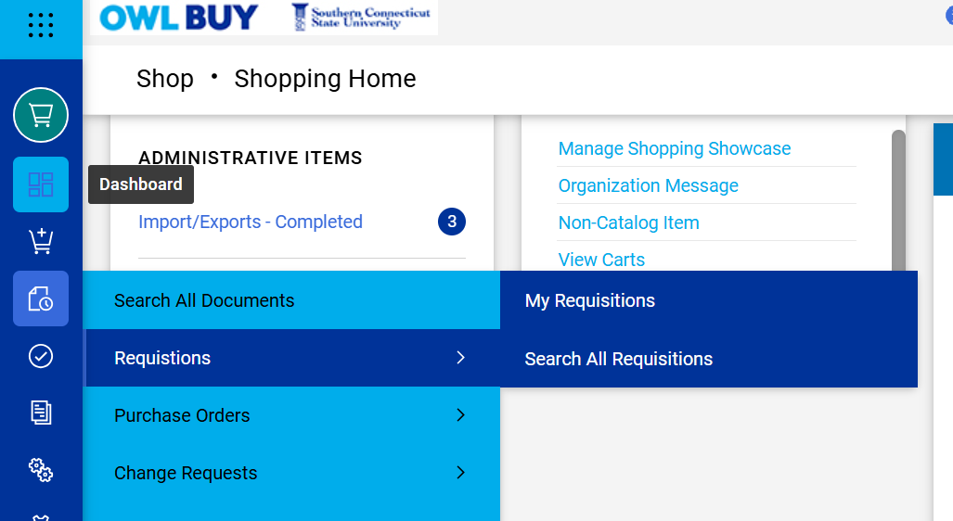
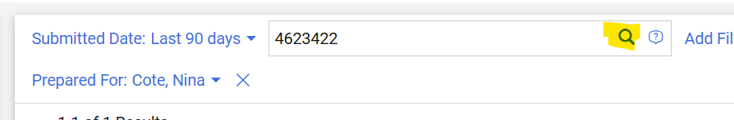

Searching for Purchase Orders
- To locate a purchase order:
  - Select Orders from the main navigation menu.
  - Select My Purchase Orders.
  - Enter the purchase order number or other search criteria.
  - Select the magnifying glass or ENTER.
  - Select the purchase order number from the results list to view details.
    - Purchase Orders can be searched using supplier information, requester names, document status, and date ranges.
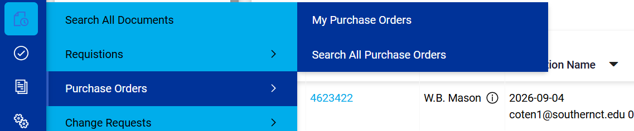

Searching by User
- Users can search for documents created or submitted by a specific individual.
  - Open the appropriate search page for requisitions or purchase orders.
  - Add Filter for Prepared By or Prepared For
  - In the Prepared By or Prepared For field, enter the user's name.
  - Select Search.
  - Review the resulting list of documents associated with that user. [
This search is useful when assisting another employee or reviewing purchasing activity within a department.
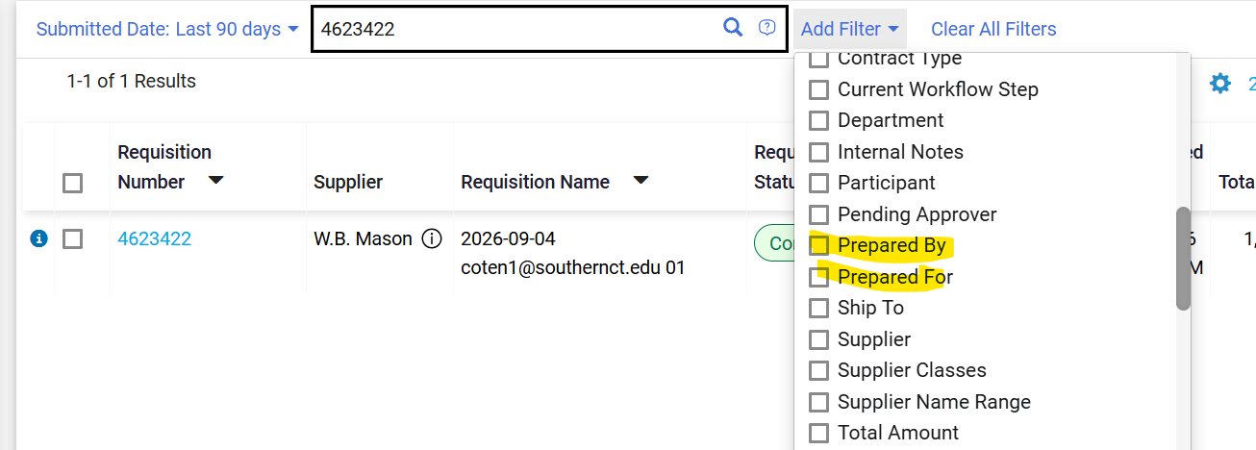

Searching by Vendor
- To locate transactions associated with a specific supplier:
  - Open either Search All Documents, Search Requisitions or Search Purchase Orders.
  - Use the Quick Filter to select a Supplier, or the Search
  - Review all documents associated with the selected supplier.
Use this search method when reviewing spending, locating prior purchases, or verifying orders placed with a particular vendor.
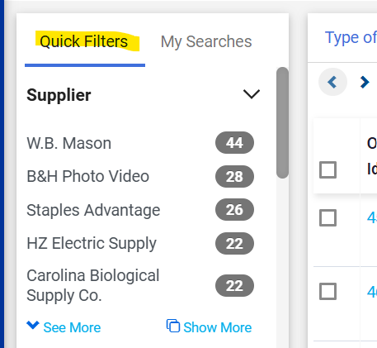

Searching by Date Range
- Date range searches allow users to find documents created during a specific period.
  - Open either Search All Documents, Search Requisitions or Search Purchase Orders.
  - Update Created Date to the appropriate dates
  - Search.
  - Review the results.
Date range searches are commonly used when reviewing monthly, quarterly, or fiscal-year purchasing activity.
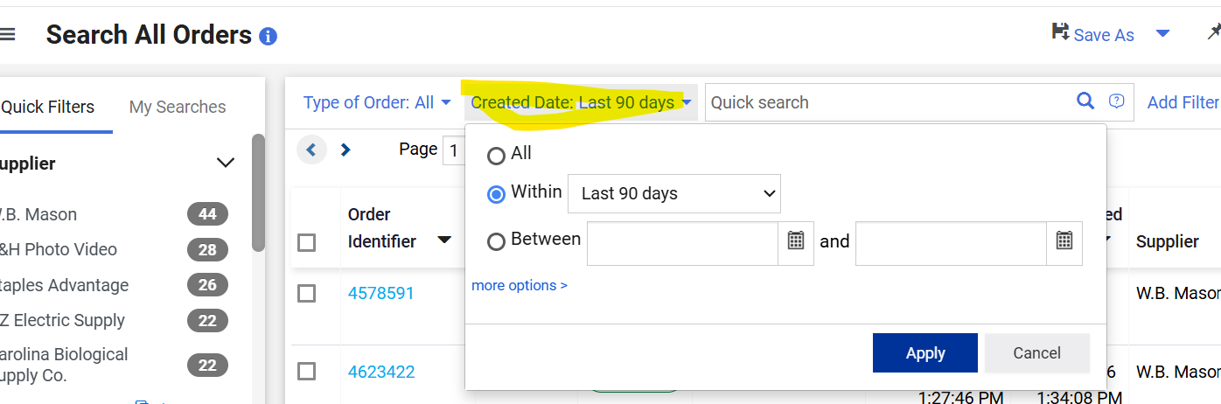

Searching by Status
- Users can search for requisitions or purchase orders based on their current status.
- Common statuses include:
  - Cancelled – The document has been canceled and will not continue through the procurement process. No further action will be taken on the document.
  - Complete – All required workflow steps, approvals, and processing activities have been completed for the document.
  - Pending – The document is awaiting action, such as completion by the requester, approval by a reviewer, or processing by Procurement Services.
  - Rejected – The document was denied by an approver or reviewer and cannot proceed in its current form. A new document or significant revisions may be required.
  - Returned – The document has been sent back to the requester for correction, additional information, or modification before it can continue through workflow.
  - Withdrawn – The requester has removed the document from workflow before final approval processing was completed. The document is no longer active and may require resubmission if still needed.
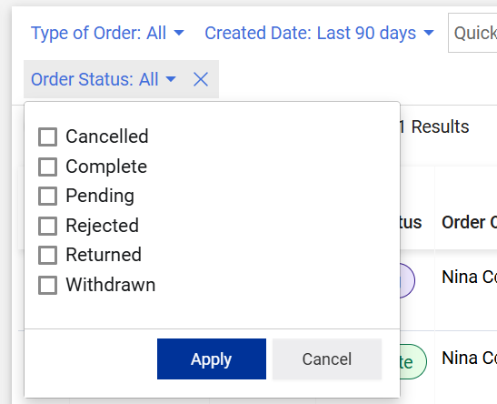

Viewing Document History
The Document History section provides a complete audit trail of activity associated with a requisition or purchase order.
- To view document history:
  - Open the requisition or purchase order.
  - Select the History tab.
  - Review the listed activities.
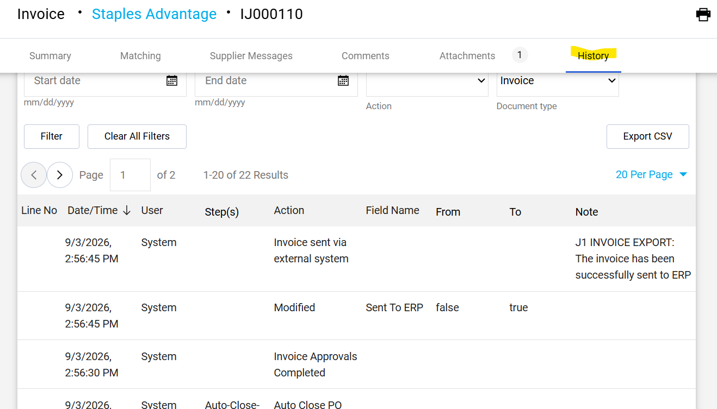

Tracking Approval Status
Users can monitor the approval progress of a requisition at any time.
- To view approval status:
  - Open the requisition.
  - Locate the Workflow section displayed on the right side of the document.
  - Review completed, current, and pending approval steps.
The workflow displays:
  - Completed approvals
  - Current approval assignment
  - Pending approval steps
  - Specialized reviews, such as IT, Sponsored Research, EHS, or Procurement Services, when applicable.
If a requisition is returned, the workflow will identify where the process stopped so corrections can be made.
