Quick Guide: Supplier Requests and Supplier Management
OWL Buy contains supplier records that have been approved for use by Southern Connecticut State University. To support implementation, suppliers with active direct deposit information in Banner have been migrated to OWL Buy and available for selection when creating requisitions.
Users should always search for an existing supplier before requesting a new one.

Searching for a Supplier
Before creating a requisition:
- Search for the supplier in OWL Buy.
- Review the supplier profile.
- Select the supplier record that matches your purchasing need.
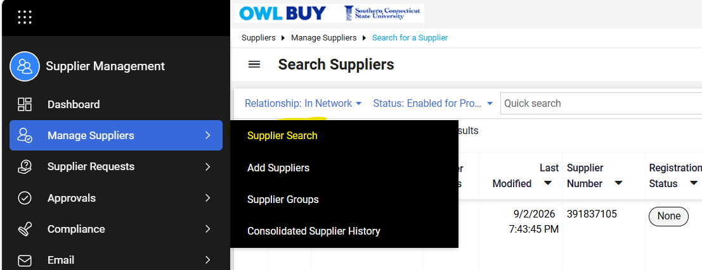

Requesting a New Supplier
If a supplier cannot be located in OWL Buy:
- Submit a New Supplier Request.
  - Supplier Request Form Options
- Entity (Non-Individual) Registration- Used for companies, organizations, consultants, and other business entities.
- Individual Registration- Used when the payee is an individual rather than a business. Examples include guest speakers, evaluators, honorarium recipients, and certain independent contractors.
  - Enter the supplier name using the format Last Name, First Name.
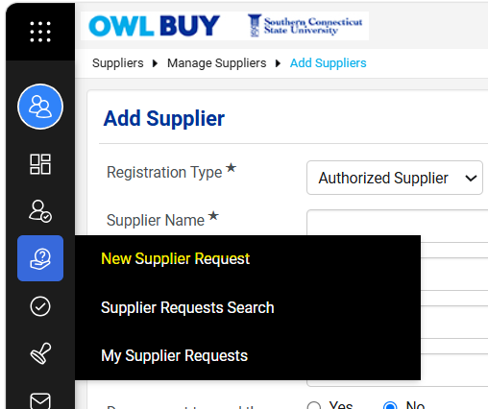

  - Certify that you have already searched for the supplier in the system and they do not exist.
  - Complete the required supplier information
  - Submit the request, and it will enter the Supplier Request Workflow, and it will be sent to the Procurement team for review.
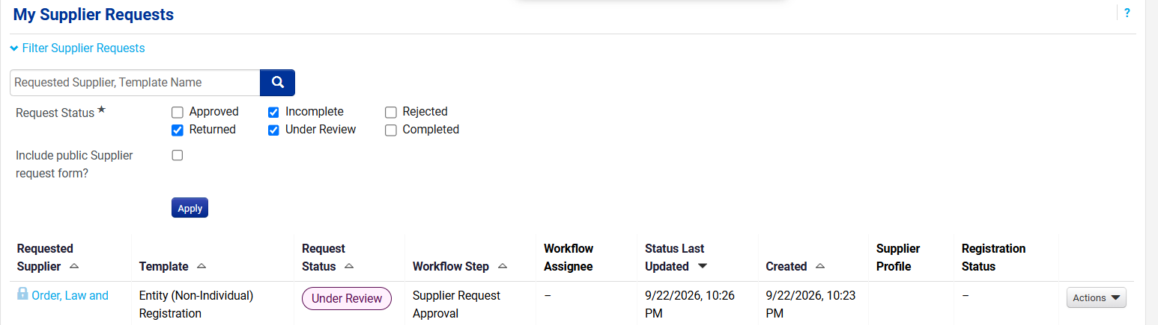

  - Once the request is approved, you will receive an email notification:
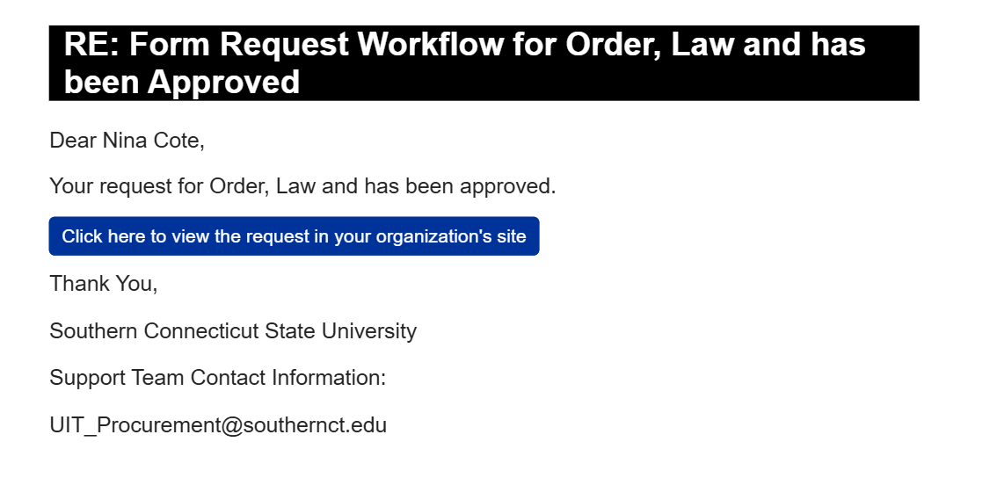
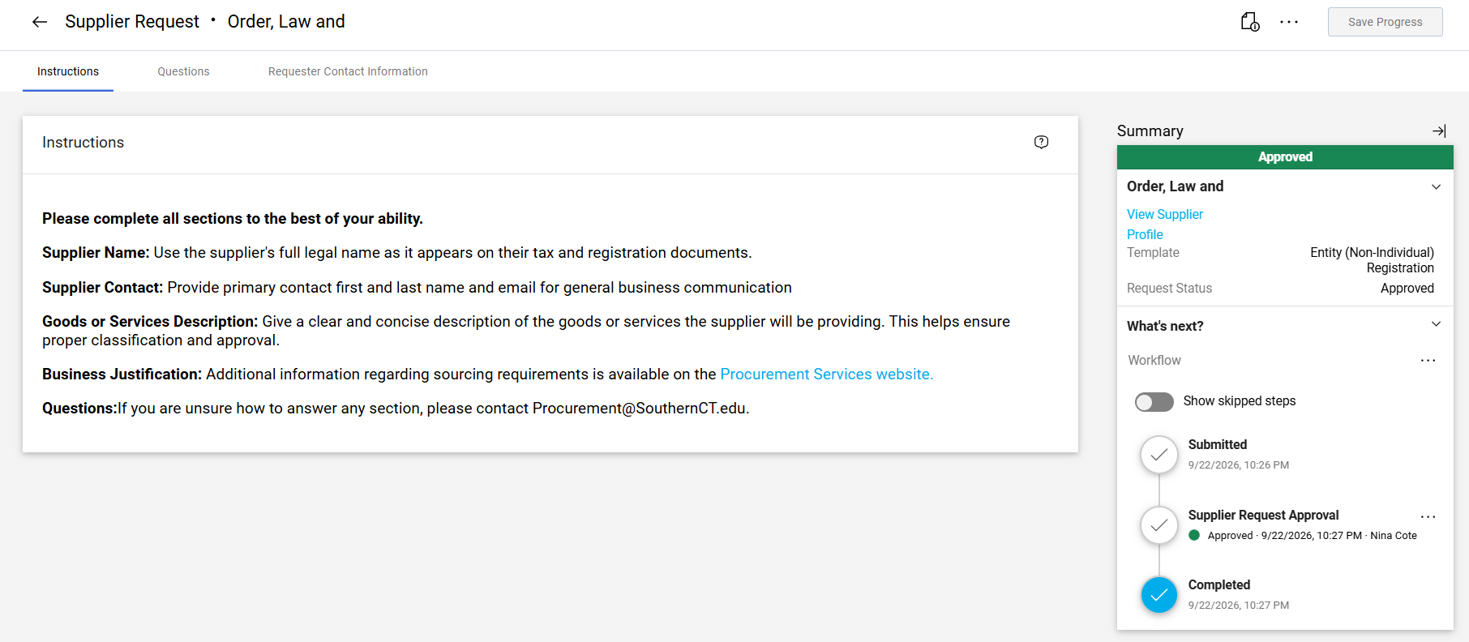

  - If you were to attempt to add the vendor again you would receive a message that a potential match may exist.

Please note: After Procurement approves the supplier request, the supplier receives an invitation to complete registration in OWL Buy. The supplier is responsible for providing all required information and documentation. Delays in supplier response may delay supplier activation. You will be emailed once the invitation is sent to the supplier.
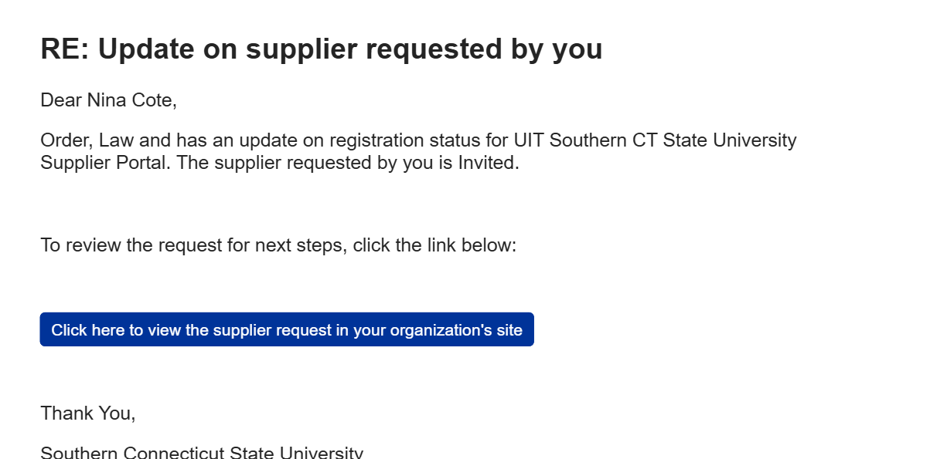

Supplier Onboarding Process
Submission of a supplier request does not immediately activate the supplier.
The supplier will complete the onboarding process which may include:
- Company Overview
- Business Details
- Contacts, including:
  - Fulfillment Contact
  - Physical Address
  - Remittance Address
- Diversity Information
- Tax Information
Additional Requirements
- Suppliers performing work on campus may be required to provide a Certificate of Insurance (COI) as part of the registration and approval process.
- Direct deposit enrollment is required for all domestic suppliers.
- If a supplier indicates that they cannot accept direct deposit payments, the registration will be routed through workflow to Accounts Payable for review and approval prior to supplier activation.

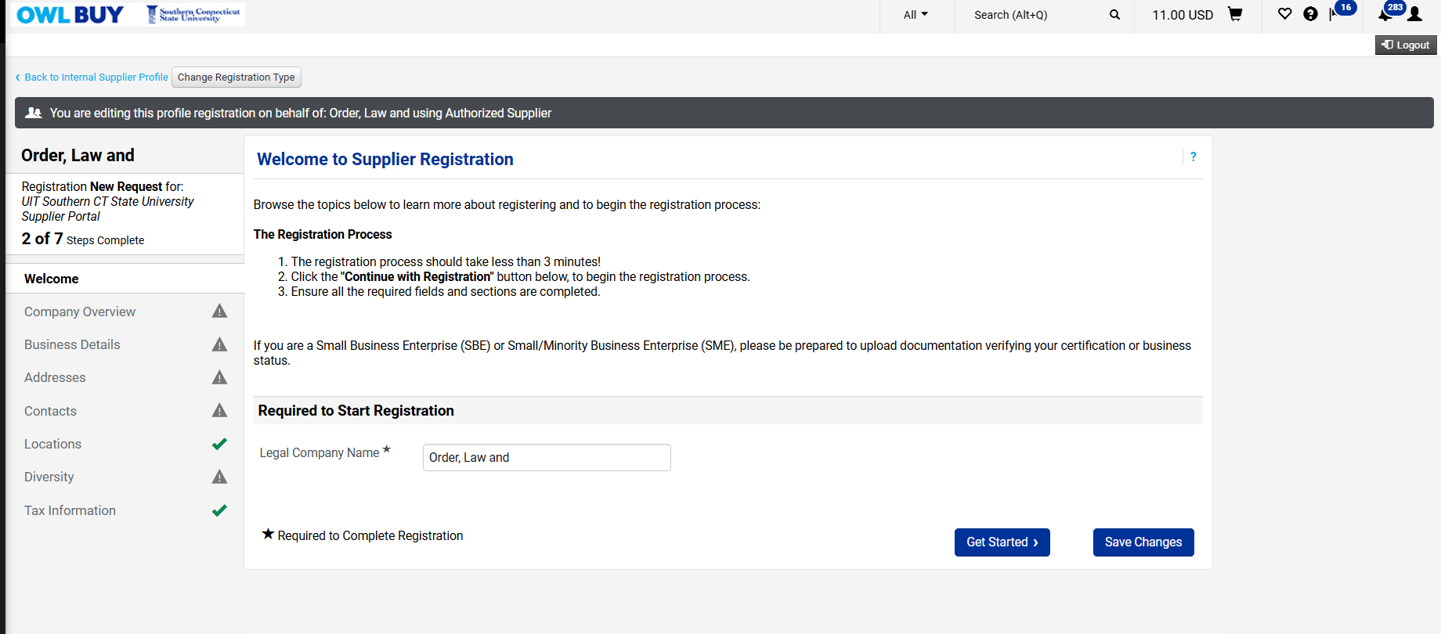
- Supplier registrations may undergo some or all of the following reviews:
Workflow | Purpose | Review Owner
OFAC Check | Federal sanctions screening | Automated/System
Duplicate Supplier Review | Prevent duplicate supplier records | Procurement
TIN Validation | Verify tax ID and legal name | Automated/System
Diversity Verification | Validate diversity certifications | Procurement
Nonresident Alien Tax Review | Tax compliance review | Accounting
Direct Deposit Review | Banking and payment method review | Accounts Payable

Once approved, the supplier will be available for use in OWL Buy.

