Quick Guide: Shopping and Searching in OWL Buy

Shopping and Searching Catalogs
- The Search Bar is the primary tool used to locate products, suppliers, contracts, forms, and non-catalog purchasing options within OWL Buy.

Searching for Products and Services
- To search for an item:
  - Enter a keyword, product name, manufacturer, supplier name, or part number in the search bar.
  - Select the Search icon (magnifying glass) or press Enter.
  - Review the search results.
  - Select the desired item.
  - Add the item to your shopping cart. 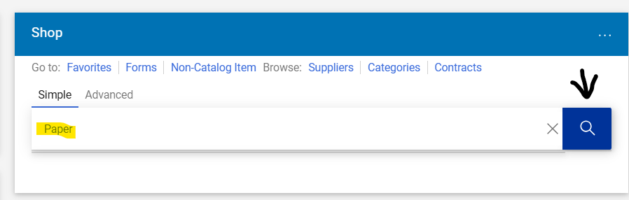
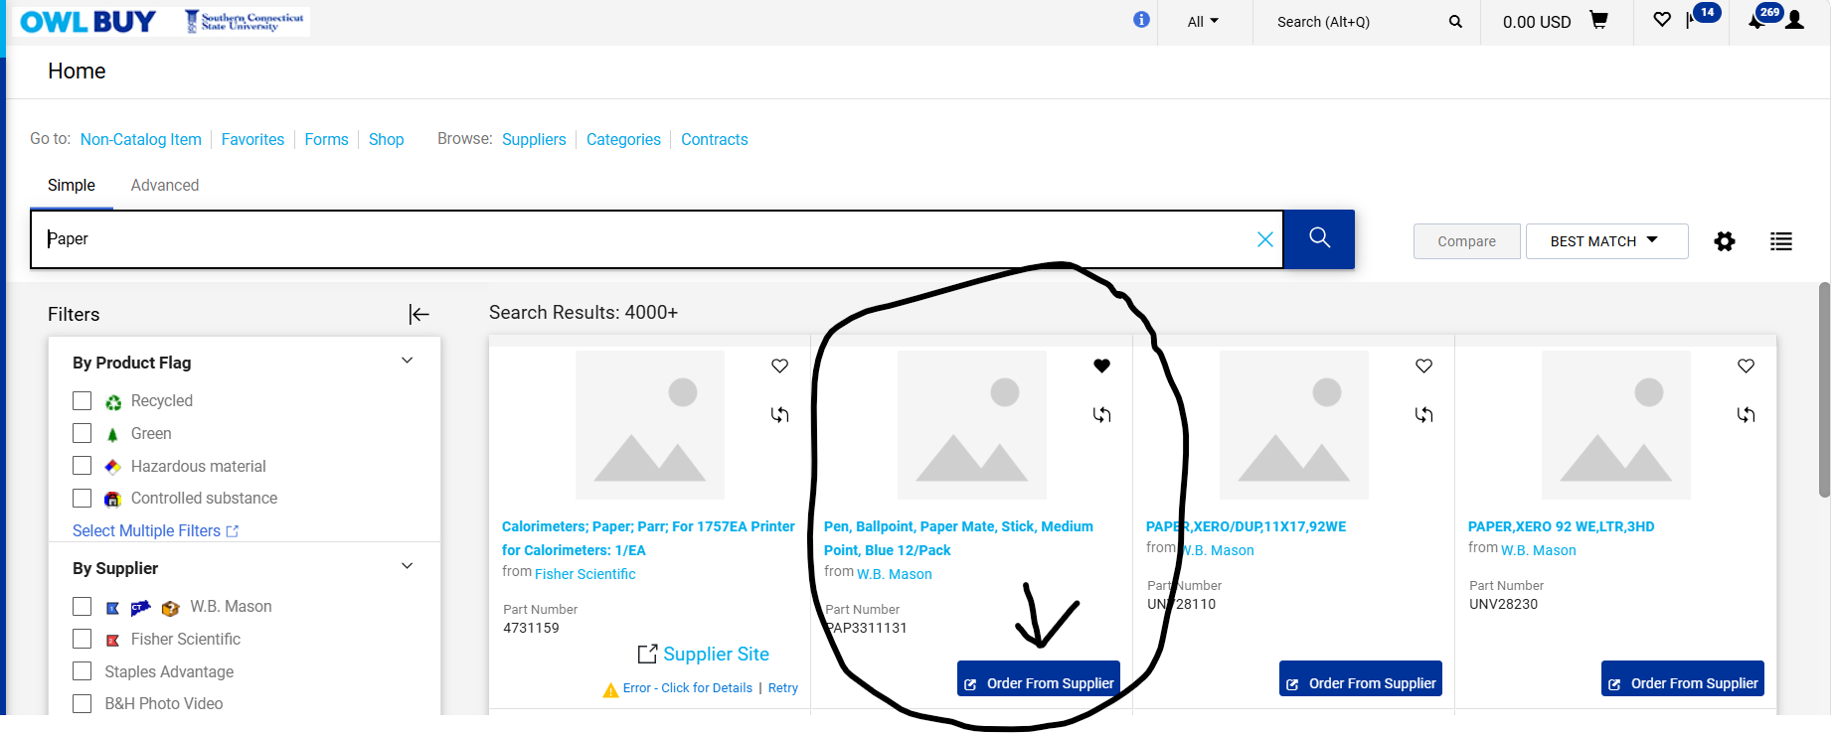
- Search Tips
  - Use specific keywords whenever possible.
  - Search by manufacturer part number when known.
  - Use alternative keywords if initial results do not return the desired item.
  - Apply available filters to narrow results by supplier, category, contract, or price.
  - Search by supplier name or contract number when looking for existing agreements. 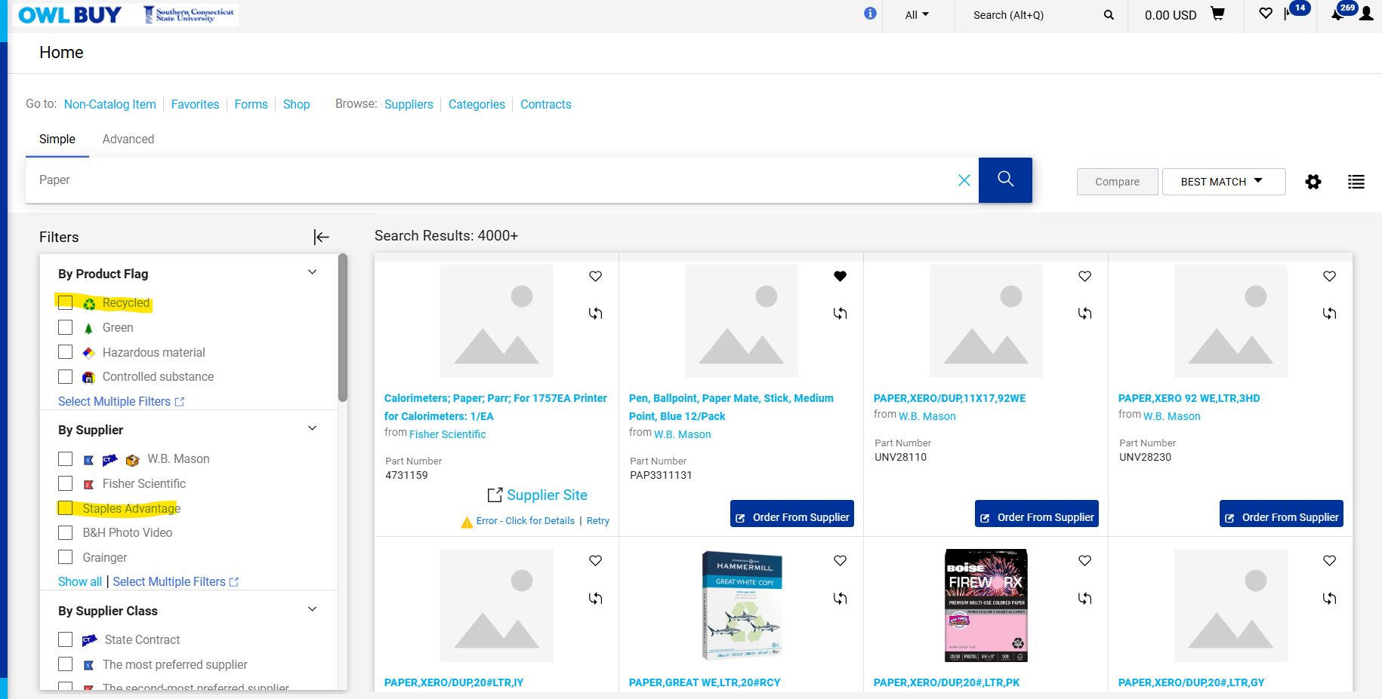
- Simple Search vs. Advanced Search
  - Simple Search: Performs a basic keyword search across products, suppliers, forms, and contracts.
  - Advanced Search: Provides additional filtering options that help users locate specific products, suppliers, contracts or documents more efficiently.

Browsing Supplier Catalogs
University-approved supplier catalogs can be accessed in several ways:
- Select a supplier from the Showcases section.
- Browse through Suppliers or Categories.
- Search directly using the search bar.
Catalog Types
OWL Buy supports two types of supplier catalogs.
- Hosted Catalogs- Hosted catalogs display supplier products directly within OWL Buy. Users can:
  - Search for products
  - Compare items
  - Add items to their cart
  - Complete shopping without leaving the system

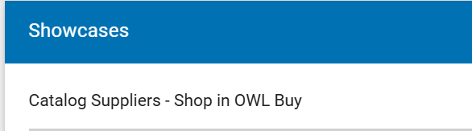
- Punch-Out Catalogs- Punch-out catalogs connect directly to a supplier's website. To purchase from a punch-out supplier:
  - Select the supplier's catalog.
  - Shop on the supplier's website.
  - Add items to the supplier cart.
  - Select Checkout on the supplier website.
  - The selected items will automatically transfer back to your OWL Buy cart.
  - Continue shopping or proceed to checkout.
Items from multiple suppliers may be combined into a single shopping cart.
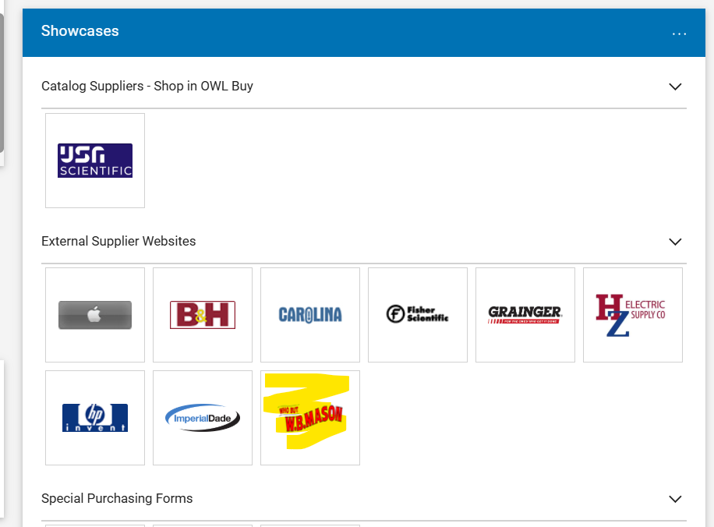

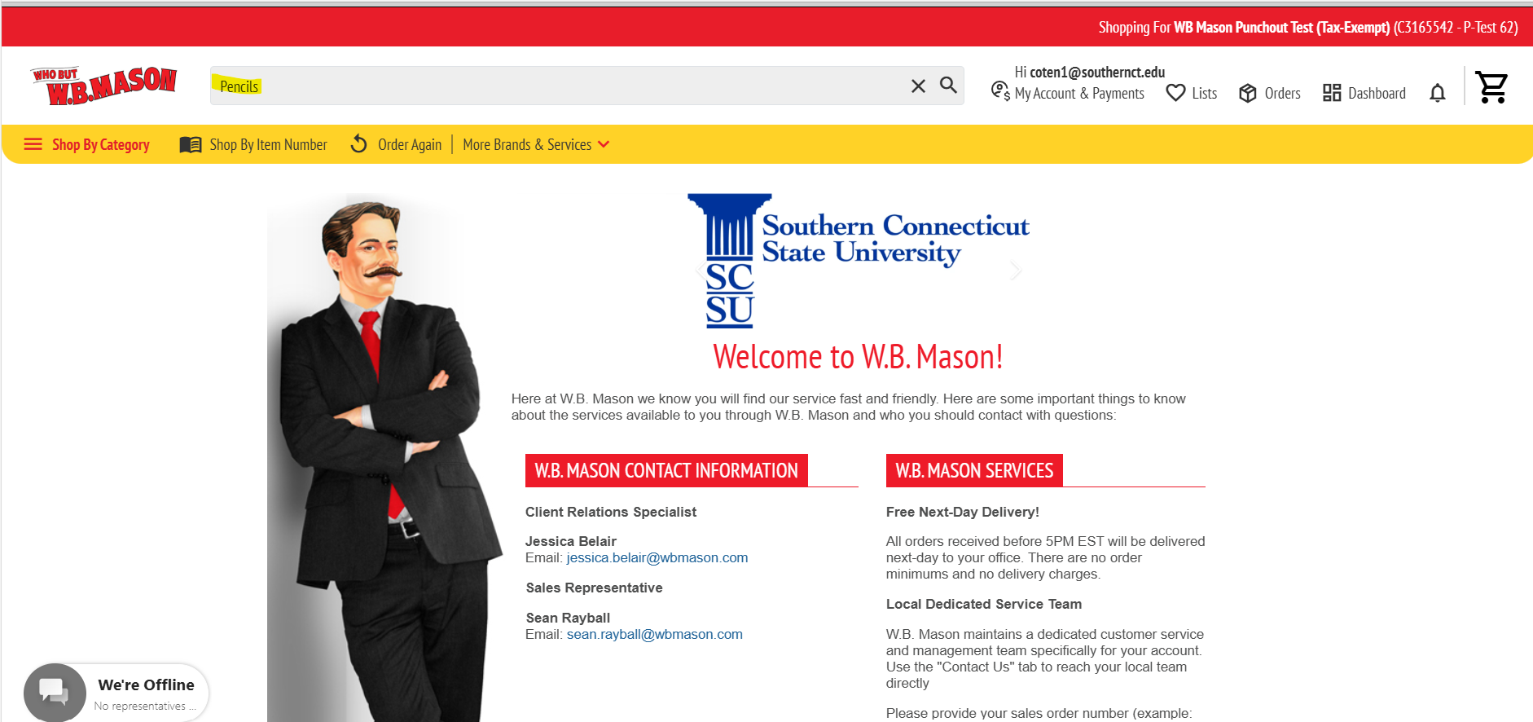
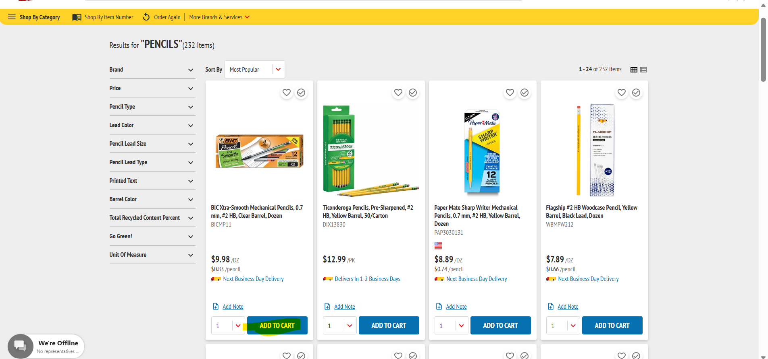
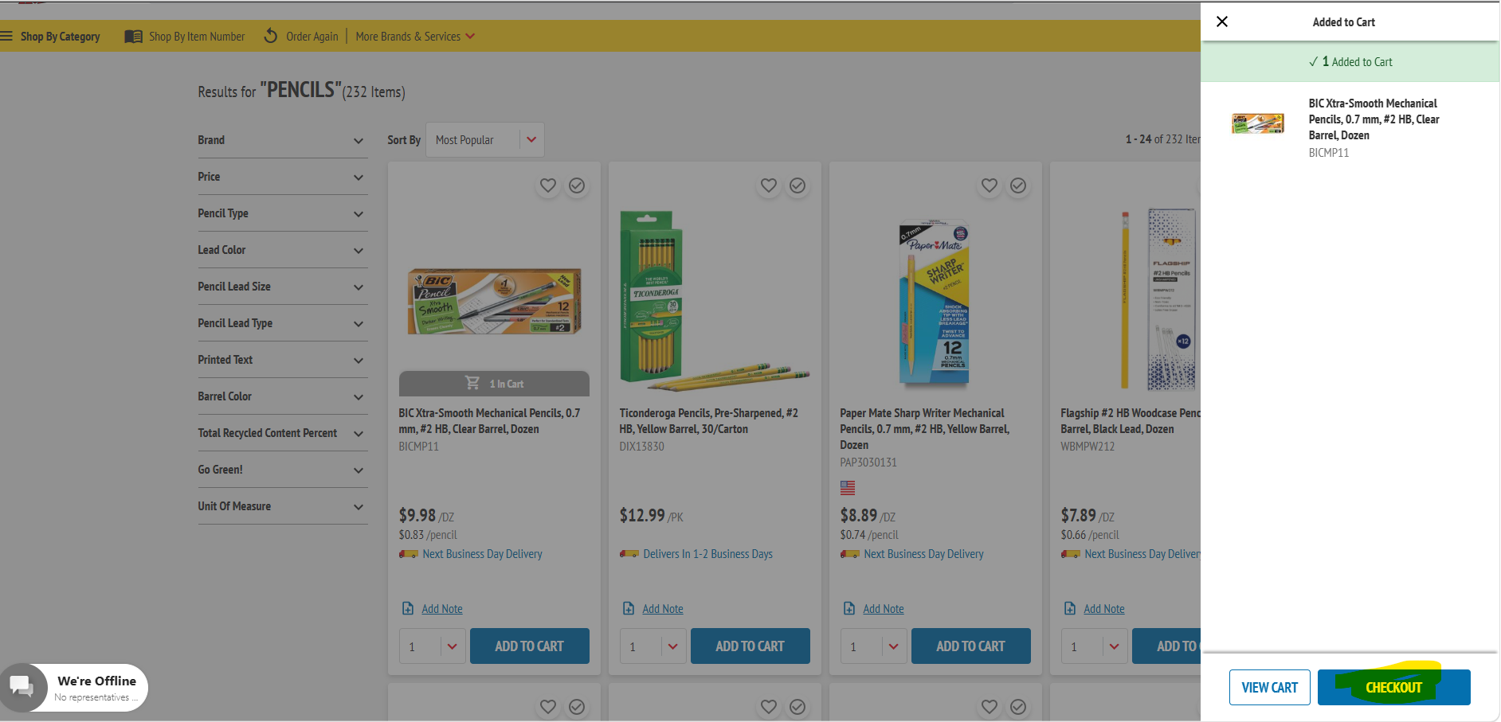
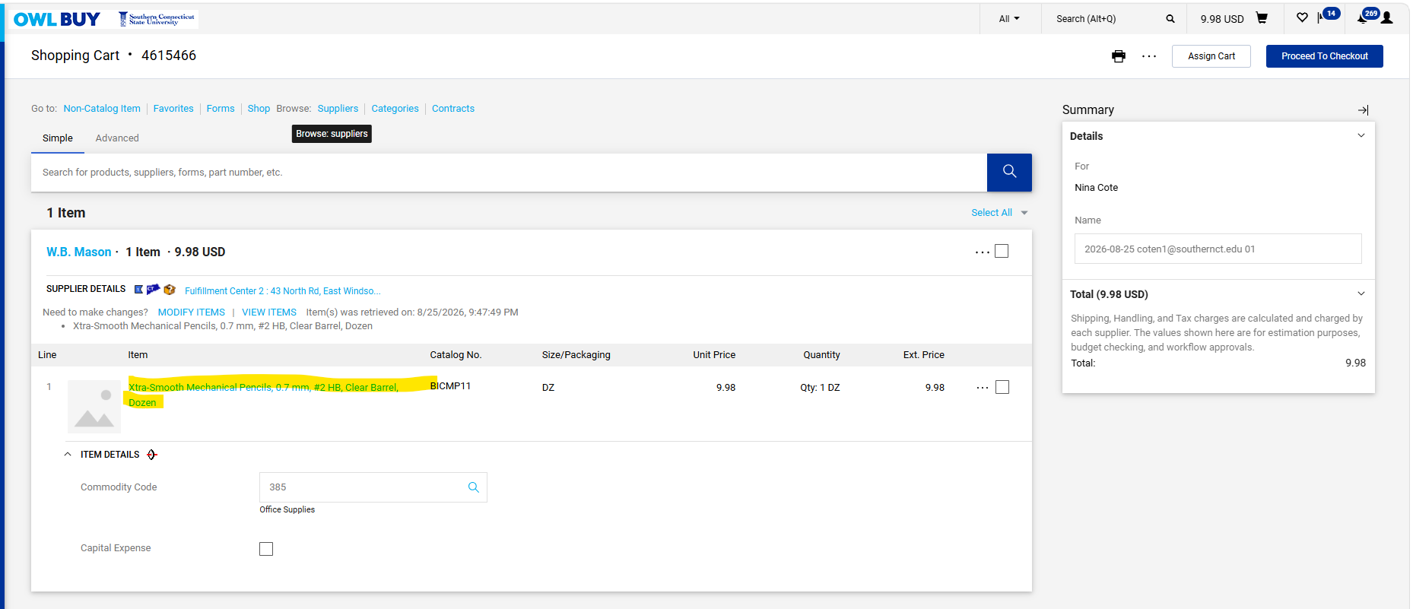
- Non-Catalog Purchases- If an item cannot be located through an approved supplier catalog, select the Goods and Services Form.
  - Best Practice: Before creating a non-catalog request, search approved supplier catalogs to confirm the item is not already available. Catalog purchases generally provide the most efficient ordering process and may offer contracted pricing and negotiated terms.
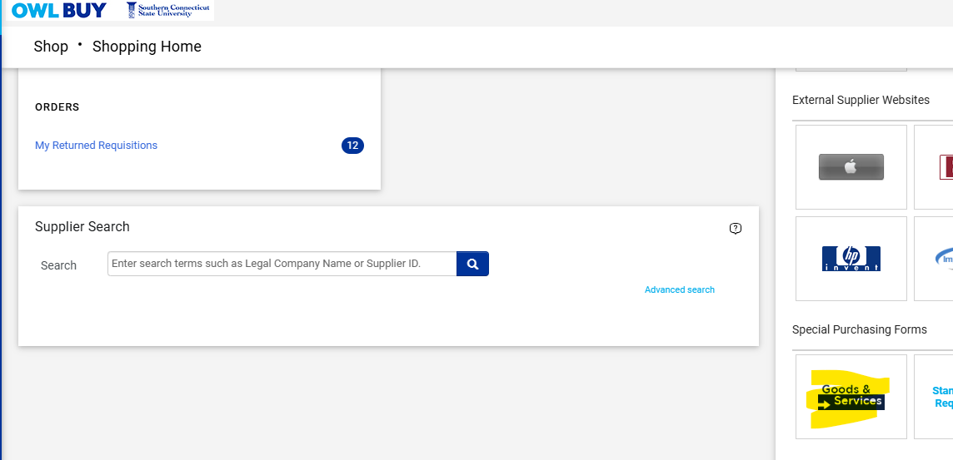
- The Non-Catalog Item Form guides users through the information required to create a compliant requisition. During the process, users will be prompted to:
  - Select the supplier from the list of suppliers already available in OWL Buy.
  - Identify the appropriate sourcing method and procurement category.
  - Indicate whether the purchase is for goods or services.
  - Determine the number of requisition lines.
  - Complete required item attributes.
  - Enter pricing and quantity information.
  - Attach quotes, proposals, contracts, or other supporting documentation when required.
  - Provide any additional information necessary for Procurement Services to review the request.
The questions presented on the form may vary depending on the type of purchase being requested. Completing the form accurately will help ensure that the requisition is routed correctly and processed as efficiently as possible.

System Notifications
OWL Buy generates notifications when action is required or when important updates occur.
- Common notification types include:
  - Approval requests
  - Returned transactions
  - Requisition updates
  - Supplier registration updates
  - Invoice status updates
  - Contract workflow updates
- Accessing Notifications:
  - Select the Notifications icon
  - Review the message details
  - Open the transaction if action is required
Users should review notifications regularly to ensure timely processing of procurement transactions.
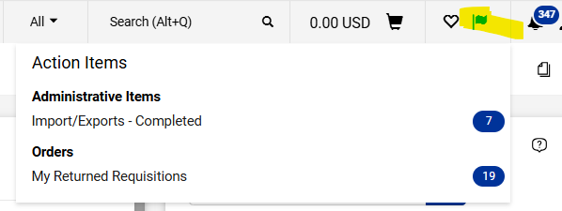

Searching for Transactions
- In addition to searching for products and suppliers, OWL Buy allows users to search for existing procurement transactions and records. Users can search for:
  - Requisitions
  - Purchase Orders
  - Suppliers
  - Invoices
  - Contracts
  - Forms and Requests
- To Search
  - Select the Search icon or search field
  - Enter a keyword, transaction number, supplier name, or other search criteria.
  - Select Search.
  - Apply filters as needed to narrow the results.
  - Open the desired record to view additional details.

