Quick Guide: Preparing and Submitting a Requisition

1. Reviewing Your Cart Before Checkout
- Before proceeding to checkout, review all items in your shopping cart to ensure the purchase is complete and accurate. Verify the following:
  - Item descriptions
  - Quantities
  - Pricing
  - Accounting information
  - Supplier information
  - Required attachments
  - If changes are needed, update the cart before moving forward with the requisition process. Taking a few moments to review your cart can help prevent delays caused by returned requisitions.

2. Adding Comments and Attachments
- Comments and attachments provide additional information to approvers and Procurement Services. To add a comment or attachment:
  - Open your shopping cart.
  - Navigate to the checkout page.
  - Select the Comments tab.
  - Select the + sign.
  - Enter your comment.
  - To attach a document, select Add Attachment.
  - Upload the required file(s).
  - Select the check mark.
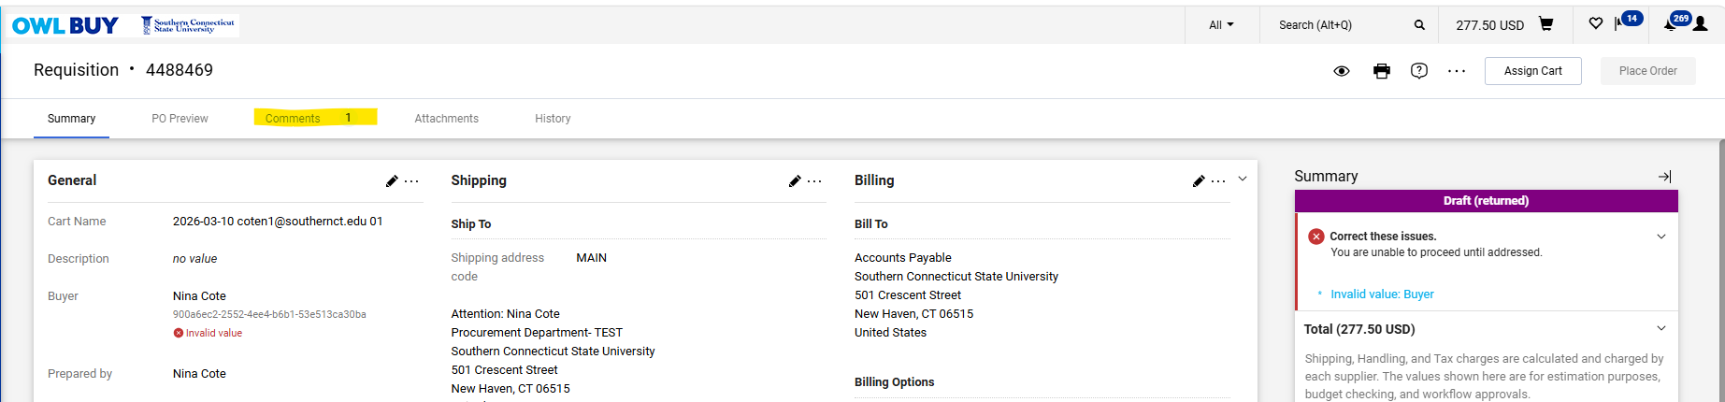
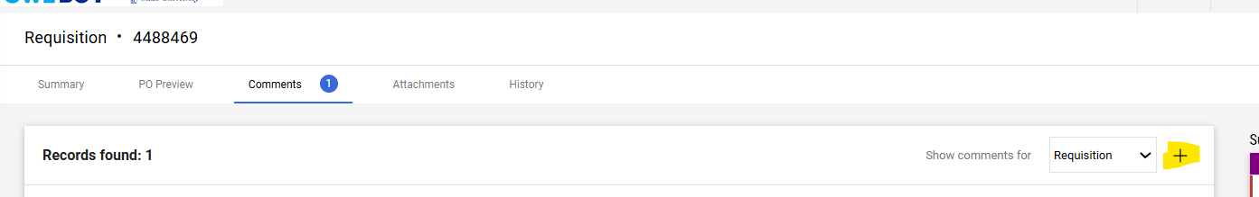
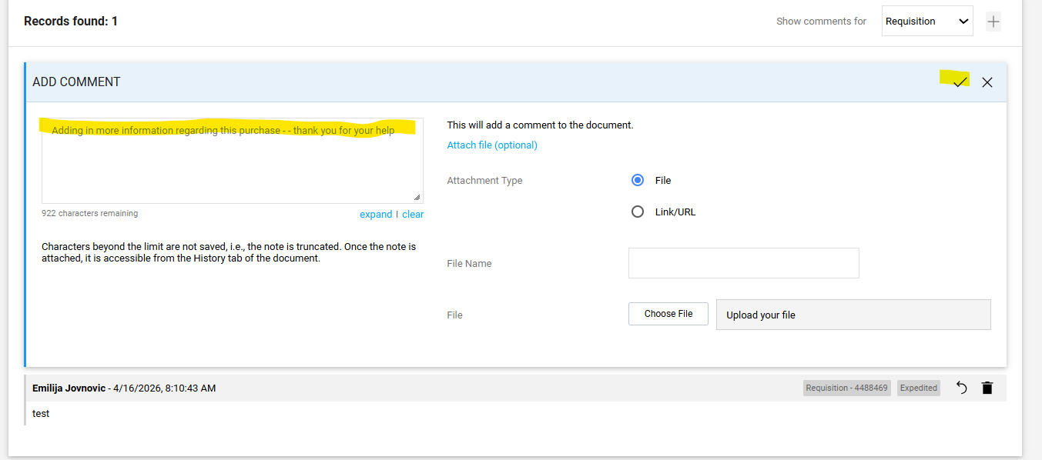

3. Adding Internal Notes
- Internal Notes can be added to a cart or requisition to provide additional information for approvers, buyers, or other members of the procurement process. These notes are not sent to suppliers and are intended for internal use only. To add an Internal Note:
  - From your shopping cart, locate the Internal Note section.
  - Select the pencil icon.
  - Enter the information you would like to share with approvers or procurement staff. Please keep notes concise and professional.
  - Select Save to add the note to the requisition.
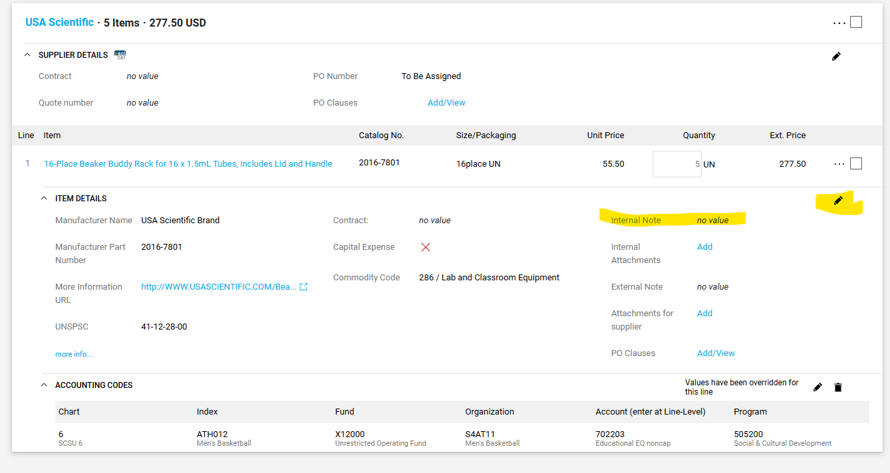
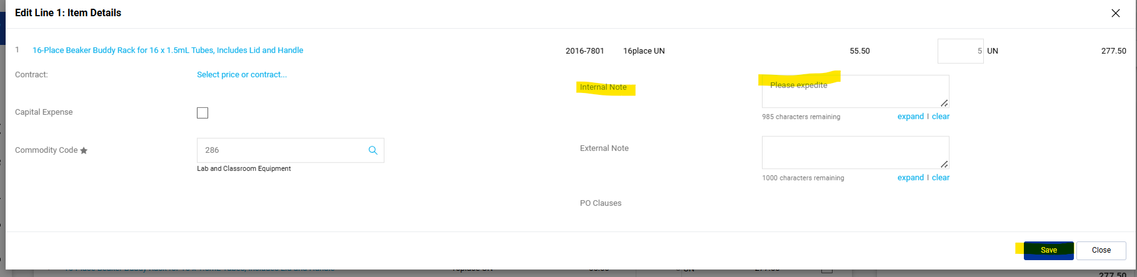

4. Selecting an Appropriate Accounting String
- OWL Buy uses Commodity Codes and Accounting Strings to ensure purchases are recorded correctly and charged to the appropriate funding source.
- Commodity Codes: A Commodity Code identifies the type of product or service being purchased. Commodity codes are assigned to catalog items and non-catalog requests and help classify purchases for reporting, budgeting, and procurement purposes.
  - Commodity codes are linked to specific account codes within the University's financial system. As a result, the commodity code selected on a requisition will limit the account codes available for selection, helping ensure that purchases are charged to the appropriate account.
  - For many catalog items, the commodity code will be assigned automatically.
  - If a commodity code is not pre-populated, the Shopper must select the commodity code that best describes the item or service being purchased.
  - Example: Lab and Classroom Supplies – Commodity Code 285 is limited to Account Code 702203 and will automatically default.
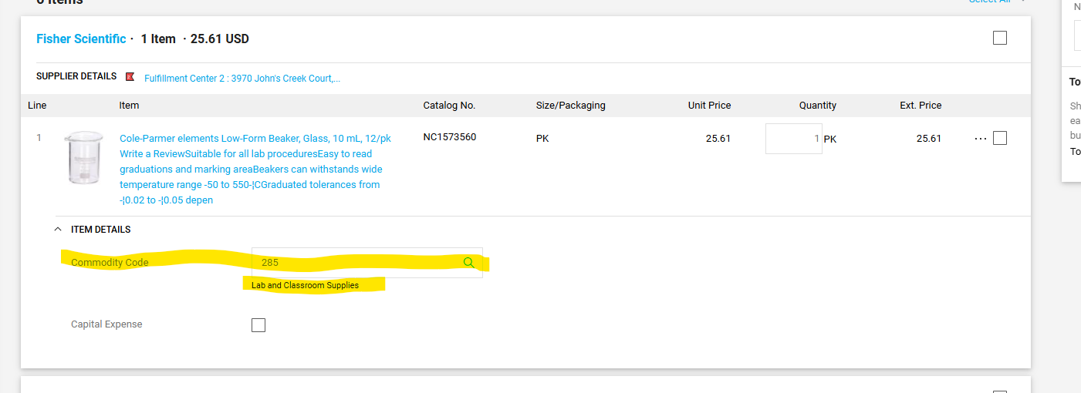
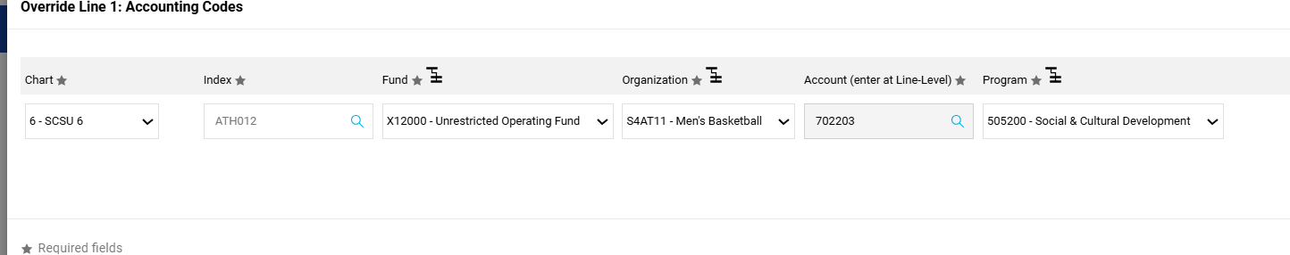
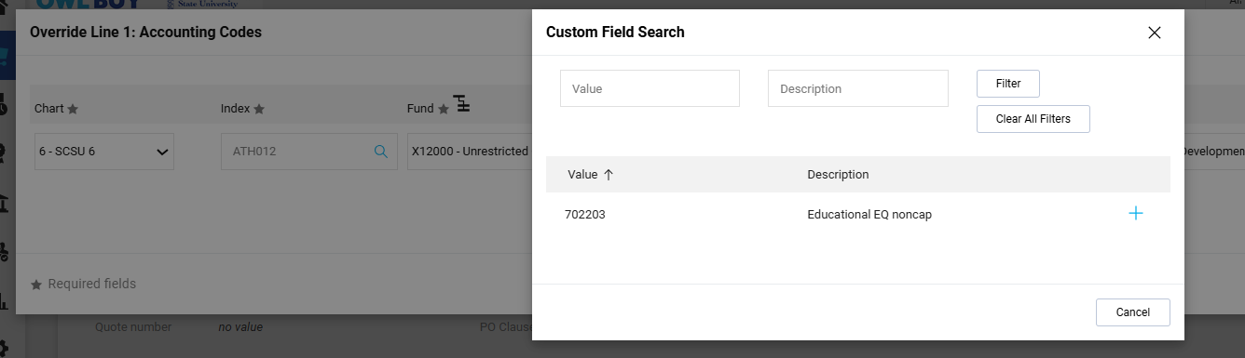
- Selecting an Index: The Index identifies the funding source that will be used to pay for the purchase. During checkout:
  - Navigate to the Accounting Codes section.
  - Enter or search for the appropriate Index.
  - Once selected, the associated Fund, Organization, and Program values will automatically populate.
  - Verify the information is correct before proceeding.
    - Important: The first step in the Purchase Requisition workflow is a budget check. If sufficient budget is not available, the purchase requisition will fail and be returned to a draft cart.
- Header vs. Line-Level Accounting: Accounting information may be entered at either the Header level or the Line level.
  - Header Accounting- Header accounting applies the same accounting string to all line items in the requisition. Use Header Accounting when:
    - All items are being charged to the same Index.
    - All items use the same funding source.
    - No allocation between departments or funds is required.
This is the most efficient method when all purchases are being charged to a single budget.
- Line-Level Accounting- Line-level accounting allows different accounting strings to be assigned to individual line items. Use Line-Level Accounting when:
  - Different items are being charged to different Indexes.
  - Costs need to be split between departments, grants, or funding sources.
  - Certain items require different account classifications.

Submitting a Requisition for Approval
- Once all required items have been added to your cart and the necessary information has been completed, the requisition must be submitted for approval. To submit a requisition for approval:
  - Review all cart details, including accounting information, supplier information, and item quantities.
  - Resolve any validation errors displayed on the cart (Examples below).
  - Select Proceed to Checkout.
  - Verify that all required fields are completed on the requisition.
  - Select Place Order to submit the requisition into the approval workflow.
  - After submission, the requisition status will change from Draft Cart to Submitted and will be routed to the appropriate approvers based on SCSU’s approval rules.
Error Examples:
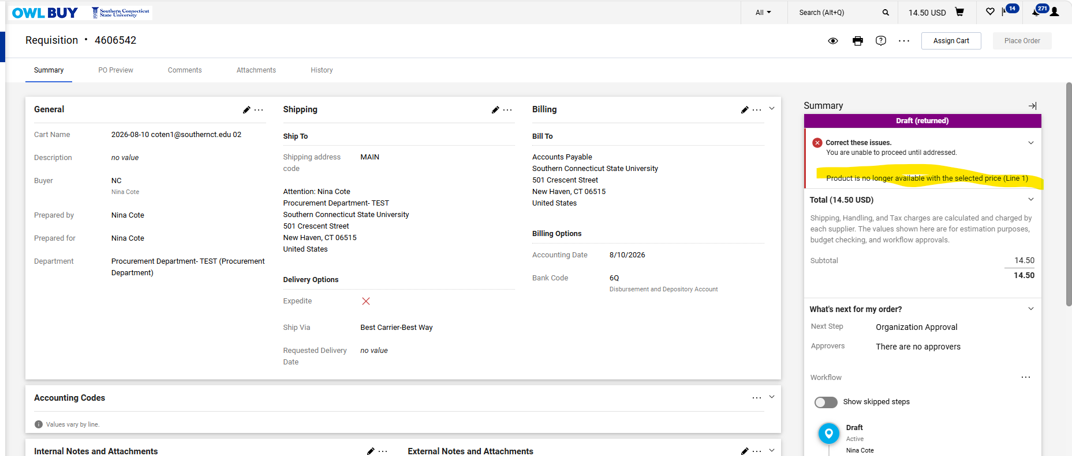
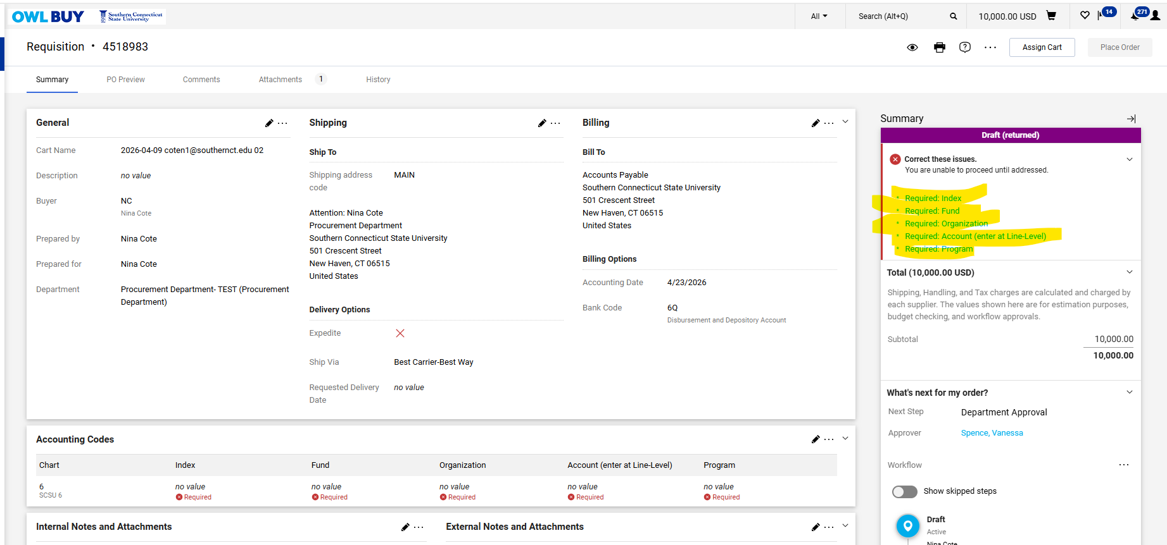
Once Requisition is submitted to the Workflow:
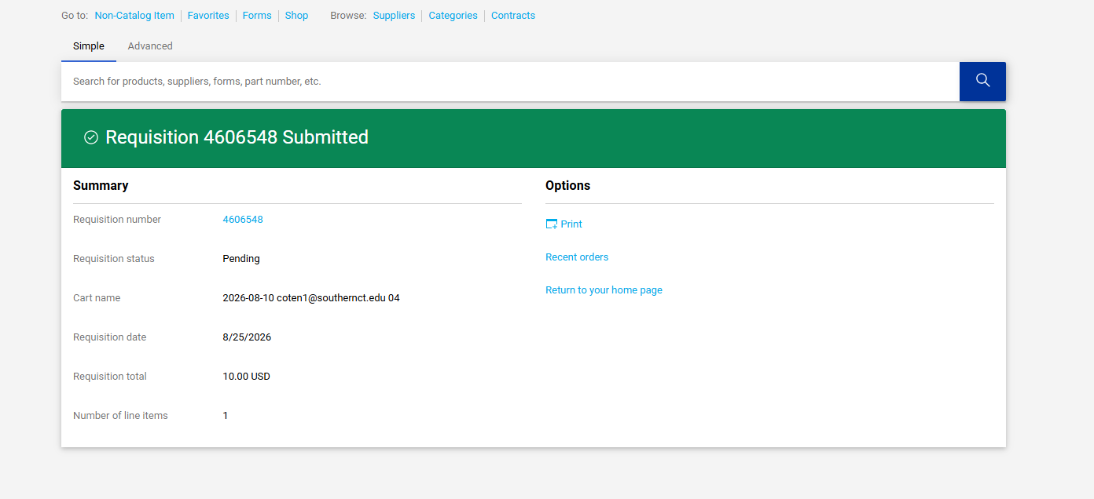

Understanding the Approval Workflow
- Once a requisition is submitted, it is automatically routed through the appropriate approval workflow based on the type of purchase, dollar amount, funding source, and other institutional requirements. The applicable workflow for your purchase is displayed on the right-hand side of the requisition.
- The workflow begins with an initial budget check to verify that sufficient funding is available. If funding is not available, the requisition will fail and be returned to a draft cart for correction.
- Approval routing is based on the total value of the requisition:
  - Purchases under $5,000 are routed to the Budget Authority identified within the organization's hierarchy.
  - Purchases of $5,000 or more are routed to the appropriate Delegated Authority for approval based on the Division.
- Depending on the nature of the purchase, additional workflow reviews may be required, including:
  - Capital Expenditure Review
  - Lab Fee Expense Review
  - Environmental Health and Safety (EHS) Review
  - Integrated Communications and Marketing Review
  - Sponsored Research Review
  - Information Technology (IT) Review for hardware and software purchases
- Only the workflow steps that apply to your specific purchase will be displayed. As approvals are completed, the requisition automatically advances to the next required reviewer.
- After all approvals have been completed, the requisition undergoes a final budget check before proceeding to purchase order creation.
- Important: Budget validation occurs twice during the requisition process: once at the beginning of the workflow and again after all approvals have been completed. Sufficient funds must be available at both stages for the requisition to proceed.

Completing a Change Order
- A Change Order is used to modify an approved requisition or purchase order after it has been created. Common reasons for submitting a Change Order include updating quantities, changing pricing, modifying accounting information, extending service dates, or making other approved adjustments to an existing purchase. To complete a Change Order:
  - Locate and open the approved purchase order requiring modification.
  - Select Change Requests tab.
  - Update the necessary information on the document.
  - Review all changes for accuracy.
  - Add an Internal Note describing the reason for the change.
  - Attach any supporting documentation related to the requested change.
  - Select Submit Request to route the Change Order through the appropriate approval workflow.
  - Once submitted, the Change Order will undergo any required reviews and approvals based on the nature of the modification. Approval requirements may differ from the original requisition and may include budget, departmental, procurement, or specialized review processes. The workflow applicable to the Change Order will be displayed on the right-hand side of the document.
