Quick Guide: Managing Your Cart
OWL Buy allows users to create, maintain and organize shopping carts before submitting a requisition. Users may have multiple carts in progress at the same time and can update, move, assign, or delete cart items as needed.

Viewing Your Shopping Carts
To access your shopping carts:
- Select the Shopping Cart icon.
- Choose one of the following options:
  - My Active Cart- The Active Cart is your current shopping cart. Newly added items are placed into this cart by default. From the Active Cart you can review selected items, update quantities, remove items, continue shopping, or proceed to checkout.
  - Manage Carts- Select Manage Carts to view all carts available to you, including:
    - Draft carts you created
    - Carts assigned to you by another user
    - Previously used carts
    - From the Manage Carts page users may open a cart, activate a cart, or delete a cart.
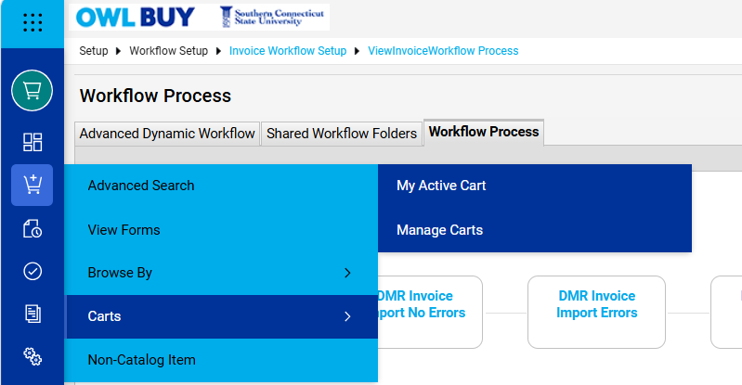

Updating Item Quantities
Item quantities may be updated at any time before the requisition is submitted.
- You can modify item quantities at any time before submitting the requisition.
  - Open your shopping cart.
  - Locate the item you wish to update.
  - Enter the revised quantity in the Quantity field.
  - Select Update if prompted.
  - Verify the revised cart total.
Note: Punch-out catalog items require you to return to the supplier’s website to modify quantities or item configurations.

Removing Items from a Cart
If an item is no longer needed, it can be removed from the cart prior to checkout.
- Open your shopping cart.
- Locate the item you wish to remove.
- Select the three dots and select Remove
The item will be removed immediately and the cart total will update automatically.

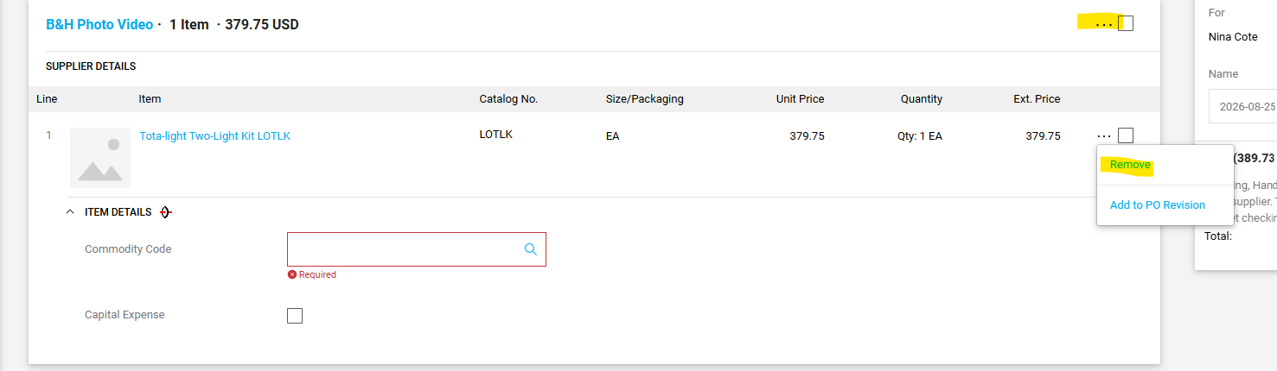

Moving Items to a New Shopping Cart
- OWL Buy allows users to move items from one shopping cart to another.
To move items to a new shopping cart:
- Open the cart containing the item(s) you wish to move.
- Select the three dots next to the item(s).
- Select Move to Another Cart.
- Choose New Cart or an existing cart.
- Select Move.
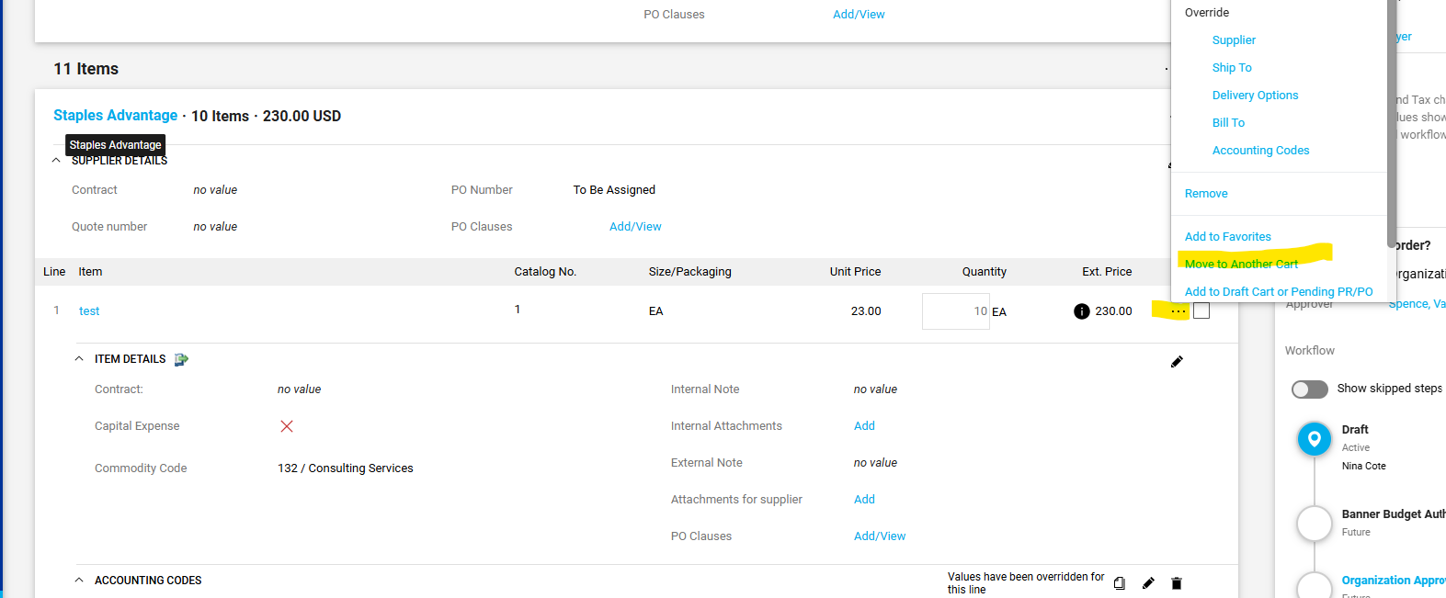
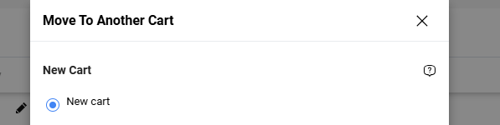

Assigning a Cart to Another User
Shoppers can assign a shopping cart to another user for review, editing, or submission. This is commonly used when a Shopper creates a cart and then assigns it to a Requestor to complete the requisition process. To assign a cart:
- Open the shopping cart you wish to assign.
- Select Assign Cart.
- Search for and select the user to whom you would like to assign the cart.
- Enter any comments or instructions, if needed.
- Select Assign.
  - Once assigned, the cart will appear in the recipient's Manage Carts page under Carts Assigned to Me.
  - After assigning a cart, the recipient becomes responsible for any additional updates and submission of the requisition. If further changes are needed, the cart can be reassigned to another user as appropriate.
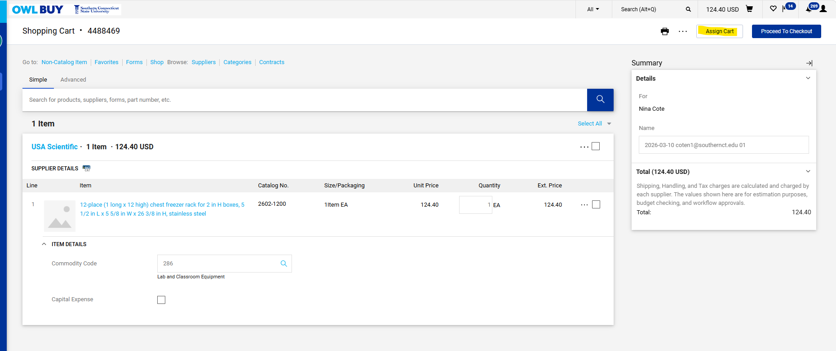
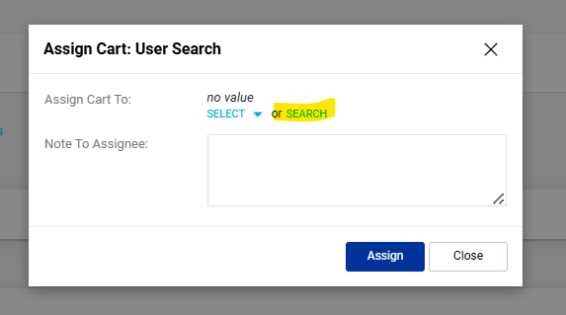
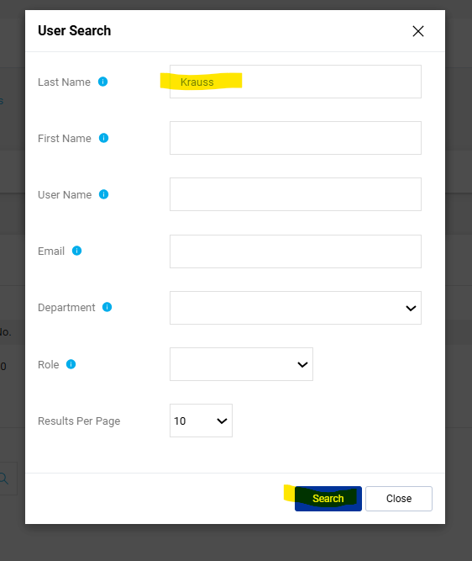
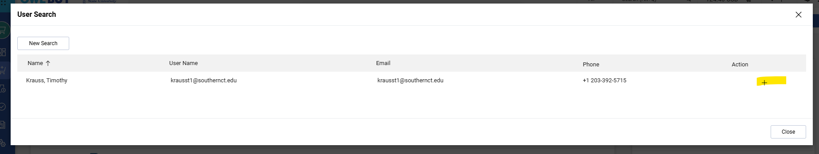
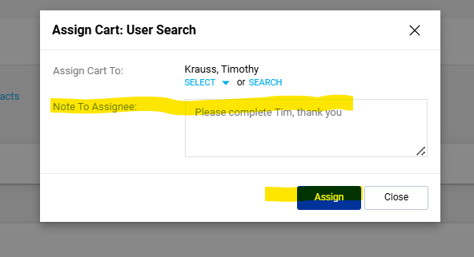

- Setting a Default Cart Assignee- If you regularly assign shopping carts to the same user, you can add them as a preferred assignee in your profile settings. This allows you to quickly select them when assigning carts in the future. To add a default cart assignee:
  - Select My Central User Profile.
  - Navigate to JAGGAER Solutions Settings.
  - Select Default User Settings.
  - Select Cart Assignees.
  - Search for and add the user(s) you frequently assign carts to.
  - Mark the appropriate user as Preferred.
  - Save your changes.
    - Once configured, your preferred assignee will appear as a suggested option when assigning shopping carts, making the assignment process faster and more efficient.
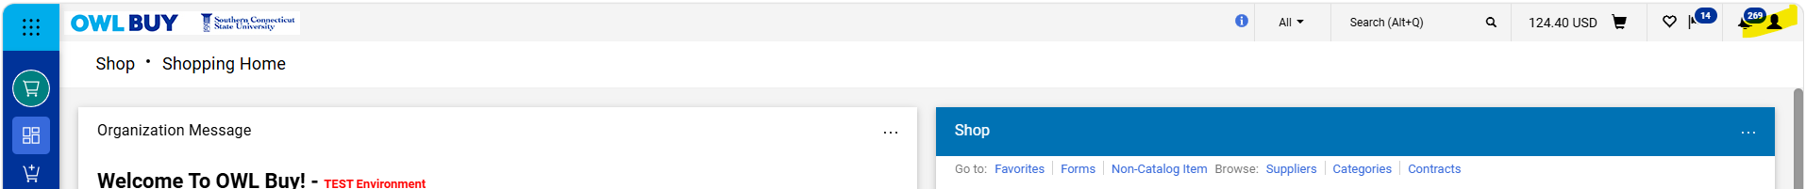

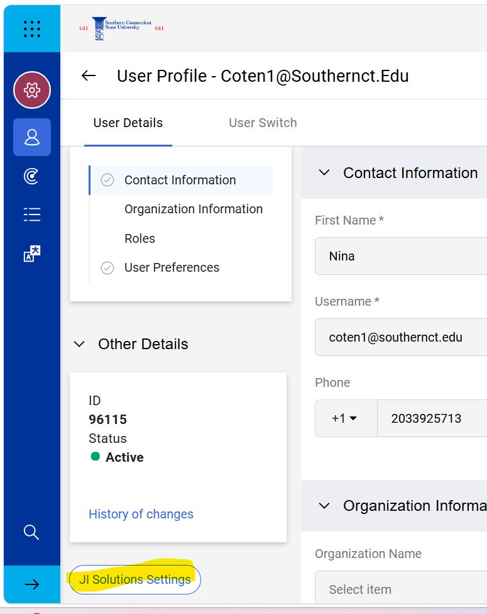
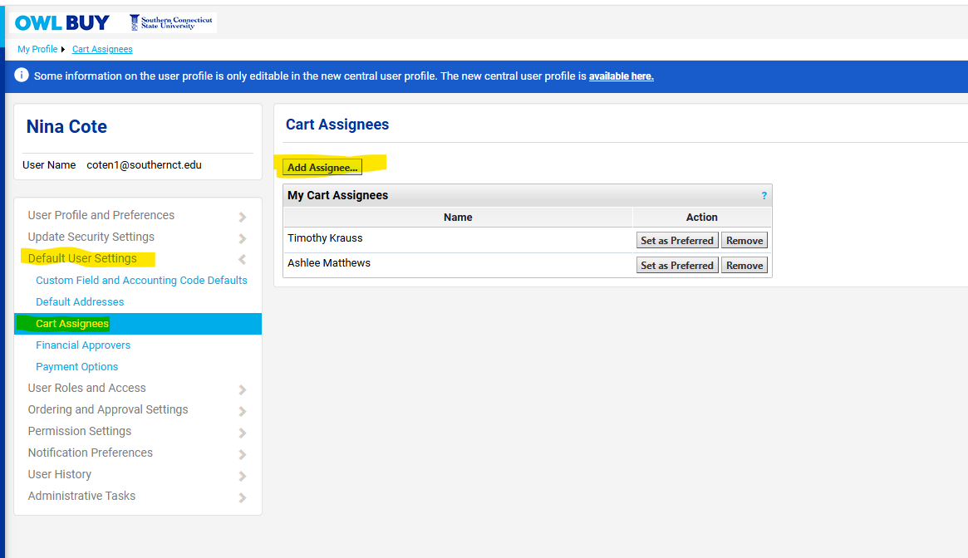

Comparing Products and Suppliers
- OWL Buy allows users to compare products side-by-side before adding them to a shopping cart. To compare products:
  - Search for the products you would like to compare.
  - Select the Compare arrow icon next to each product. You may select up to four (4) products at one time.
  - After selecting products, the Compare button will become active.
  - Review product details, pricing, suppliers, and specifications.
  - Select the desired product and add it to your shopping cart.

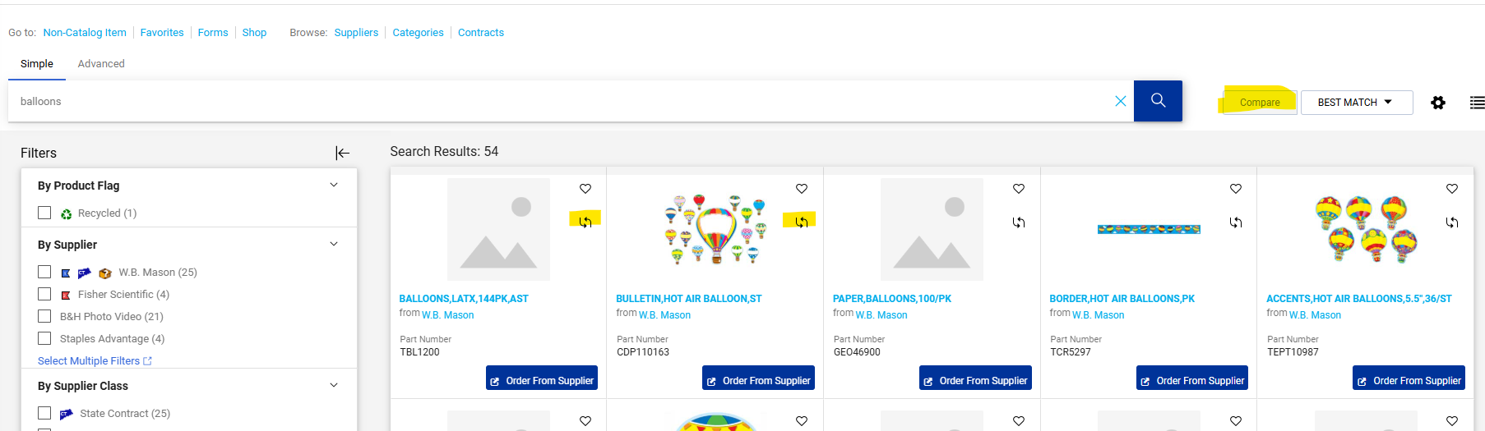
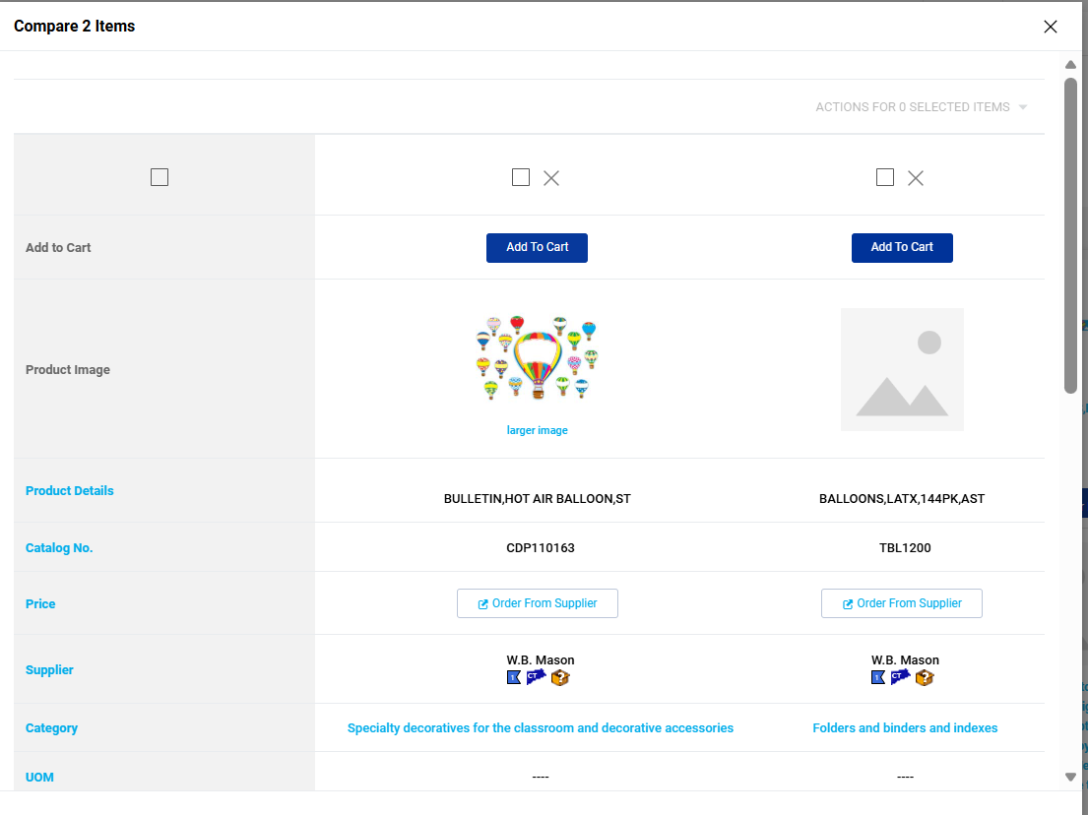

Managing Favorites

Saving an Item as a Favorite from a Catalog
- Favorites allow you to save frequently purchased items for quick access in the future. To save an item as a favorite from a catalog:
  - Locate the item you would like to save.
  - Select the Favorite (heart) icon next to the item.
  - Modify the item nickname or leave the default name unchanged.
  - Enter the quantity you would like saved as a favorite.
  - Enter a description to help identify the item in the future.
  - Select an existing Favorite Folder or create a new folder.
  - Select Save Changes.
The item will now be available from your Favorites page.
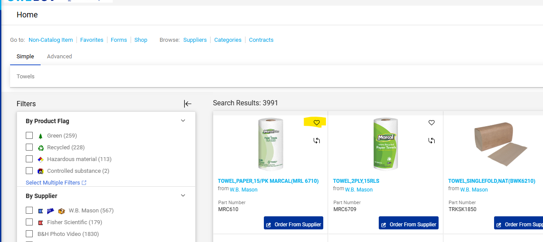
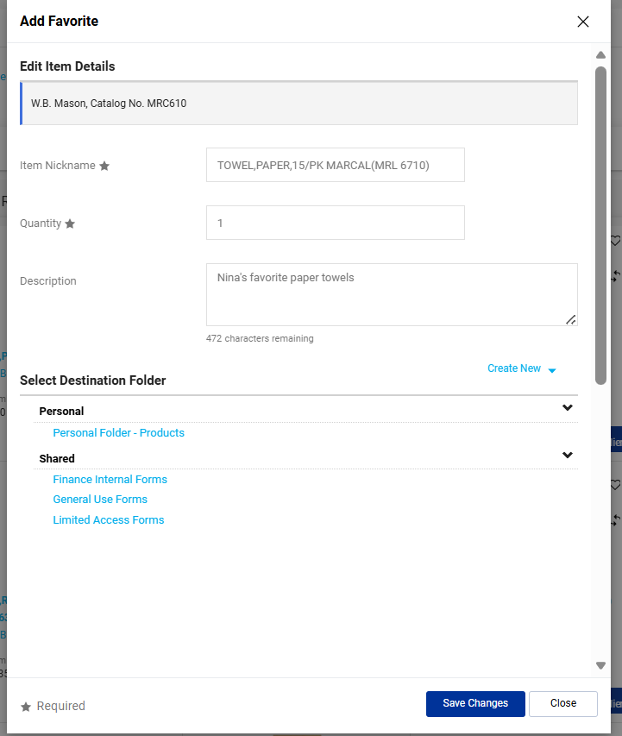

Saving an Item as a Favorite from a Shopping Cart
- Items can be saved as favorites directly from your shopping cart, making it easy to reorder frequently purchased products in the future. To save an item as a favorite from a shopping cart:
  - Open the shopping cart containing the item you would like to save.
  - Locate the item and select the three dots located to the right of the line item.
  - Select Add to Favorites.
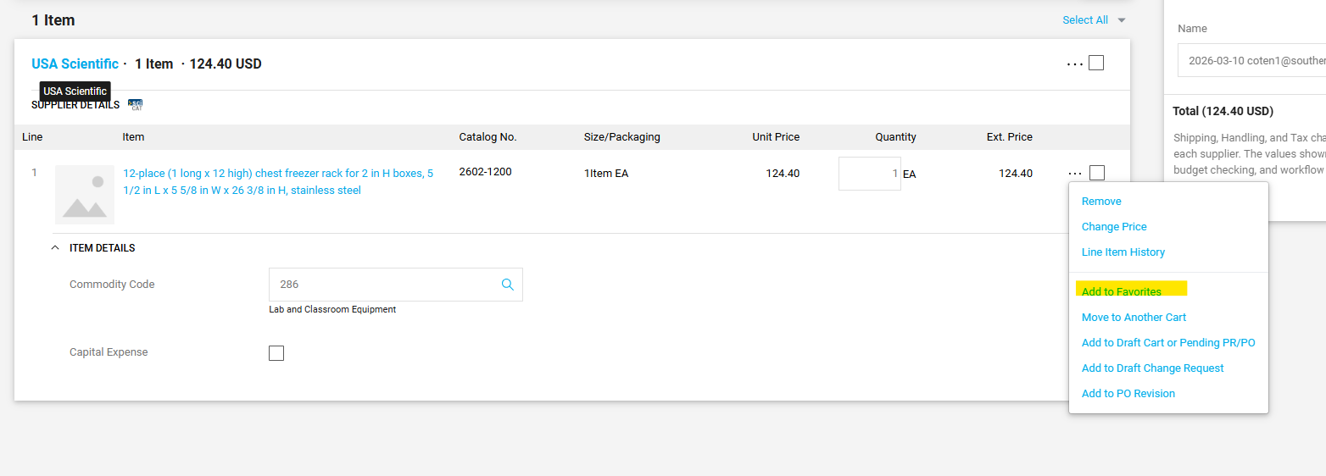

Viewing and Using Favorite Items
- Favorites provide quick access to frequently purchased items, eliminating the need to search supplier catalogs each time you place an order. To view your saved favorites:
  - Select Favorites from the Shop menu.
  - Browse your available Favorite Folders.
  - Select the desired folder to view its contents.
- From the Favorites page, you can:
  - View saved favorite items.
  - Search within your favorites.
  - Add items directly to your shopping cart.
  - Edit or remove existing favorites.
  - Create additional Favorite Folders.
