Quick Guide: Getting Started with OWL Buy

Logging In to OWL Buy
To access OWL Buy:
- Navigate to login.southernct.edu
- Select the OWL BUY icon.
- Sign in using your SCSU Single Sign-On (SSO) credentials.
- After successful authentication, OWL Buy will open automatically.
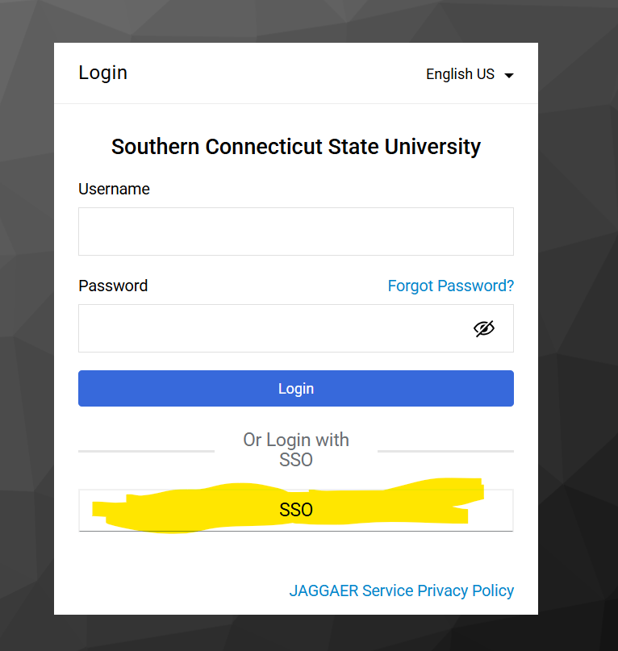

Navigating the Home Page
After logging in, you will arrive at the OWL Buy Home Page. This page serves as your central workspace for shopping, submitting requisitions, tracking purchases, managing approvals, and accessing suppliers.
- Organization Message: Located at the top of the Home Page, the Organization Message section displays important announcements, updates, and links provided by Procurement Services. Users should review this area regularly for system notices, training resources, and procurement-related communications. 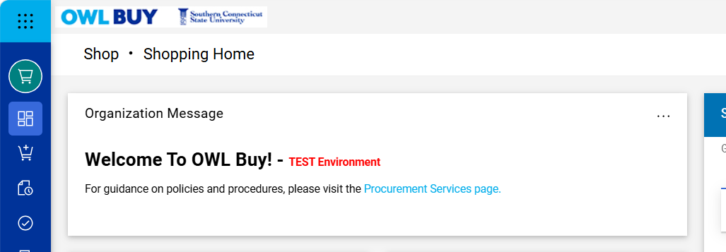
- Action Items: The Action Items panel displays tasks that require your attention. Depending on your role, this section may include:
  - Carts Assigned to Me- Shopping carts assigned to you for review or completion.
  - Returned Requisitions- Requisitions returned for correction or additional information.
  - Pending Approvals – Documents awaiting your review and approval.
The blue badge displayed next to each item indicates the number of outstanding tasks.
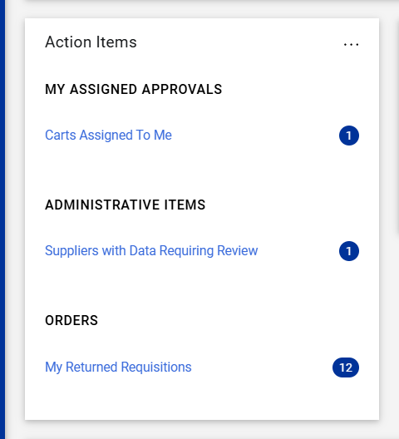
- Quick Links: The Quick Links panel provides convenient access to commonly used functions and resources.
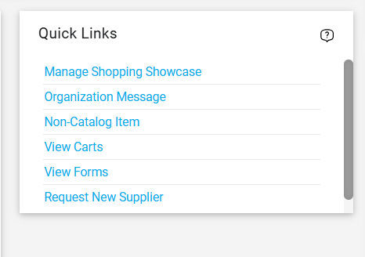
- Shop Section: The Shop Section, “Shop at the top”, is the primary area used to locate products, suppliers, forms, etc.
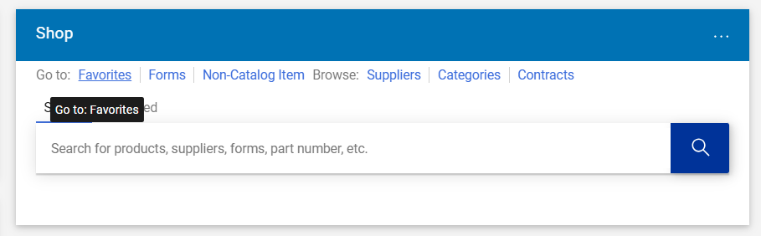
- Navigation Links: Users can quickly access:
  - Favorites – Saved products and purchasing lists.
  - Forms – Procurement forms and requests.
  - Suppliers – Approved University suppliers.
  - Categories – Product and service categories.
  - Contracts – Available University contracts.
- Showcases: The Showcases section provides direct access to frequently used suppliers and supplier catalogs. Selecting a supplier logo will take you directly to the supplier’s catalog or punch-out site, allowing you to begin shopping immediately. 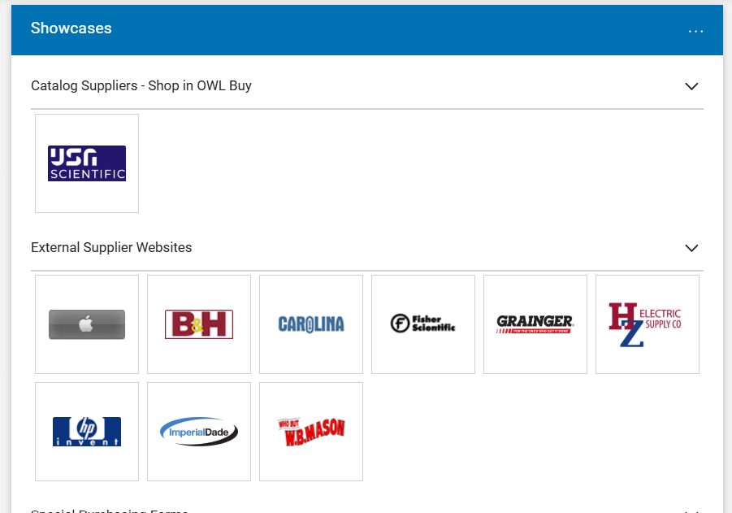
- Supplier Search: The Supplier Search tool allows users to search for supplier by:
  - Supplier Name
  - Supplier ID
  - Keyword
This feature is useful when confirming whether a supplier already exists in the OWL Buy before submitting a new supplier request.
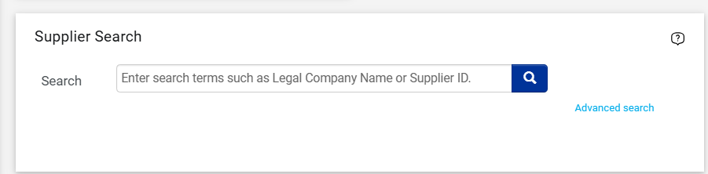
- My Profile and Menu Options: Located in the upper-right corner of the screen, the user menu provides access to:
    - Profile Settings
    - Recent Activity
    - Logout

Roles and Permissions
OWL Buy uses role-based security to ensure that users have access only to functions necessary to perform their job responsibilities.
Your assigned role determines what actions you can perform, the documents you can create or approve, and the information available to you within the system.
  - Shopper: A Shopper can browse supplier catalogs, search for products and services, and create shopping carts. Shoppers may assign completed carts to a Requestor for review and submission.
  - Requestor: A Requestor reviews shopping carts, enters required procurement information, attaches supporting documentation, and submits requisitions into the approval workflow.
  - Approver: An Approver reviews requisitions for funding availability, business purpose, and policy compliance before approving or returning the requisition for correction.
  - Procurement Services: Procurement Services personnel have additional permissions necessary to manage procurement activities and ensure compliance with CSCU policy and SCSU procedure requirements.
- If you require additional access or believe your permissions need to be modified, contact Procurement Services.

