List of Current Students Unregistered for Coming Term

You can use Navigate to find any currently enrolled students who are not yet registered for the coming semester. This search will exclude students who will be graduating, students that will be on a leave of absence and will return just those students who should be registered for the coming semester but are not yet.

- Select the Advanced Search OR Student Info Report:
To start, you have two options, you can either run this search through the Advanced Search, which will just return the list of students, or through the Reporting-Student Info report which will then include advisor assignments. See end of these instruction for suggestions as to benefits of each.

Once in the Advanced Search or Student Info report, you enter the same search parameters outlined below.

- Identify Students who have not yet registered:
Under the “Enrollment History” bucket, select the small “+” icon, this will expand your selections.
Then, in “Enrollment Terms (In Any of These)” enter the current term, for our example “Fall 2021”. Then, under “Enrollment Terms (In None of These)” enter the upcoming term, for our example “Spring 2022”. This will filter to look for students currently enrolled, who are not yet enrolled in the upcoming semester.

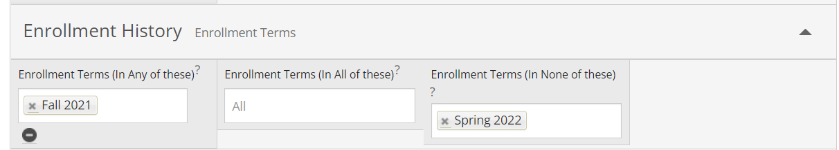

- Exclude Students Who Will Be Graduating:
In “Student Information” bucket, in “Category (In Any of These)” area, select the small “+” icon. This will open up the “Category (In None of These)” option, where you can exclude certain groups of students.
Then, in “Category (In None of These)” enter the “Degree Status: Pending Final Grades [academic year][semester code]” for students graduating in the current term and “Degree Status: In Review for Graduation [academic year][semester code]” for students graduating during the winter or summer term. You will need to enter for UG and GR if you are pulling both lists. See screen shot below for example search parameters. See description of semester codes below.

- Understanding the semester codes: The first four numbers are the end date of that academic year, then the last two numbers correspond to the semester code, listed below. So, all the semesters within the 2021-2022 academic year are listed as 2022; they year when all student would in the graduation ceremony in 2022.
Semester codes are as follows:
Fall – 10
Winter – 20
Spring – 40
Summer – 50
Example: The [academic year][semester code] you should enter following the degree status is as follows:
Fall – Next Year +10 (Fall 21 = 202210)
Winter – Year + 20 (Winter 21-22 = 202220)
Spring – Year + 40 (Spring 22 = 202240)
Summer – Year + 50 (Summer 22 = 202250)

- Exclude Students Taking a Leave of Absence:
In “Student Information” bucket, in the same “Category (In None of These)” area enter “Leave of Absence-Spring 2022” (or the upcoming semester you are interested in).

Steps 3-4 sample screen-shot:
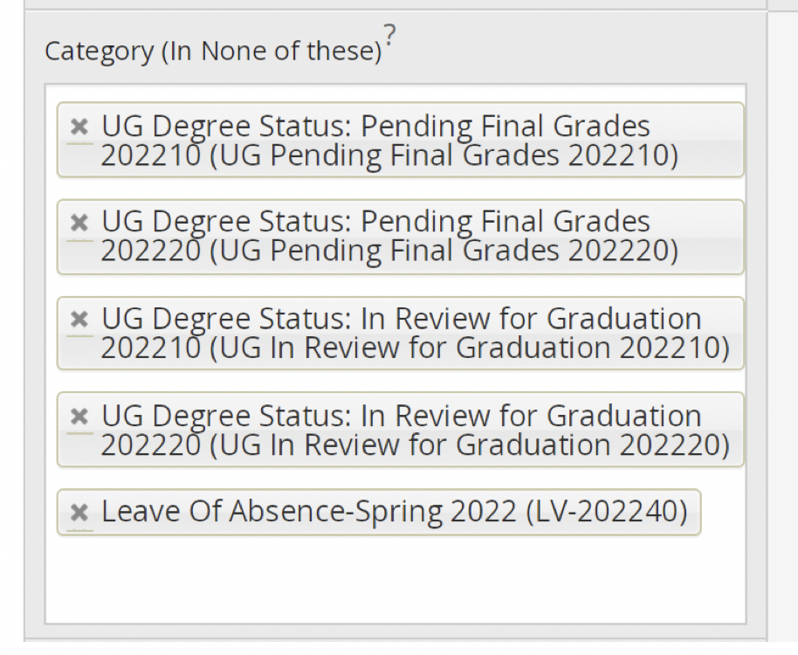

- Select specific students by Major/Degree:
In the “Area of Study” bucket, enter the major(s) and degree(s) of the students you are interested in finding enrollment information for.
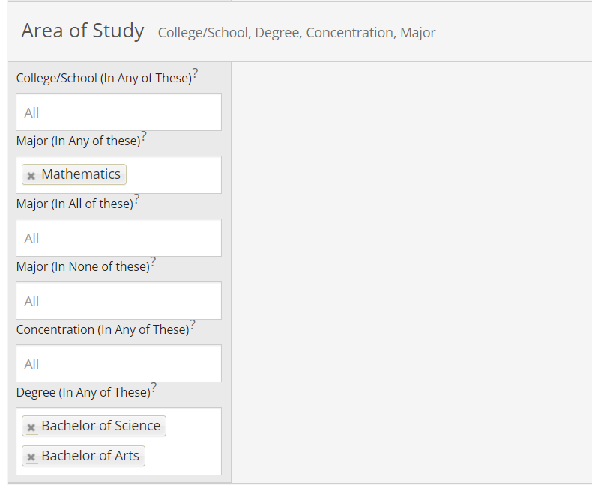

- Run the Search and Export Results:
Select “Search” and you will obtain a list of students currently enrolled, who have not enrolled in the upcoming term that are not graduating and will not be on a leave of absence. Click on the Actions carrot to select the “Export Results” option.

- Save Search Parameters if you used Advanced Search:
If you used the Advanced Search option, you can save this search and run it regularly.
Click on “Save” to name it.
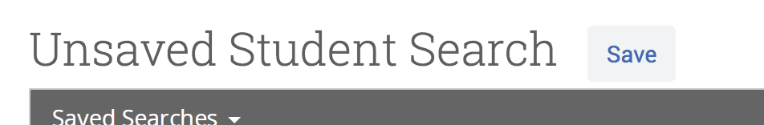

To re-run, look for the search name under the “Lists & Searches” icon.

Differences between Advanced Search OR Student Info Report:
Advanced Search Option – 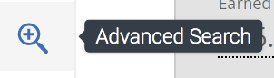
This Advanced Search option (icon on left menu) will return the list of un-registered students, but will NOT include their assigned advisor. The advantage of the Advanced Search option is that you can “save” the search and re-run it regularly without have to re-enter search parameters. This search is the best option if you don’t need or already know the advisor assignment for these students.
Reporting Option - Student Info (Active in Term) Report - 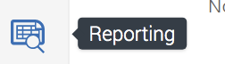
The Student Info (Active in Term) report, found under the Reporting icon on the left menu, will generate the same list of un-registered students as Advanced Search AND will also include the name of each student’s assigned advisor. This is a good option if you plan to have advisors work with students. The disadvantage is that the search parameters cannot be saved, thus re-running it requires re-entering the parameters each time.

