CSU-AAUP Faculty Research Grants
Guidelines for Spring 2022 Competition
Special Instructions for Southern Connecticut State University Faculty
Submit through Kuali Build
The following instructions are meant to amend the directions regarding submission of the CSU-AAUP Faculty Research Grants for the Spring 2022 Competition. Please review this first.

All submissions by Southern Connecticut State University faculty members for the Spring 2022 CSU-AAUP Competition must be shared with the Office of Faculty Development through submission of an electronic application in Kuali Build. Please do not submit your materials via email.

Instructions for each portion of the form are as follows.
Cover Sheet
The form on Kuali Build is intended to exactly replicate the information provided via the traditional CSU-AAUP Faculty Research Grant Cover Sheet.
The first section relates to basic contact information such as the faculty member’s name, rank, phone number, and campus address. Selecting ‘Yes’ in answer to the question ‘Is this a joint proposal?’ will cause additional fields to appear; this is the place where more names can be entered related to Co-Proposers.
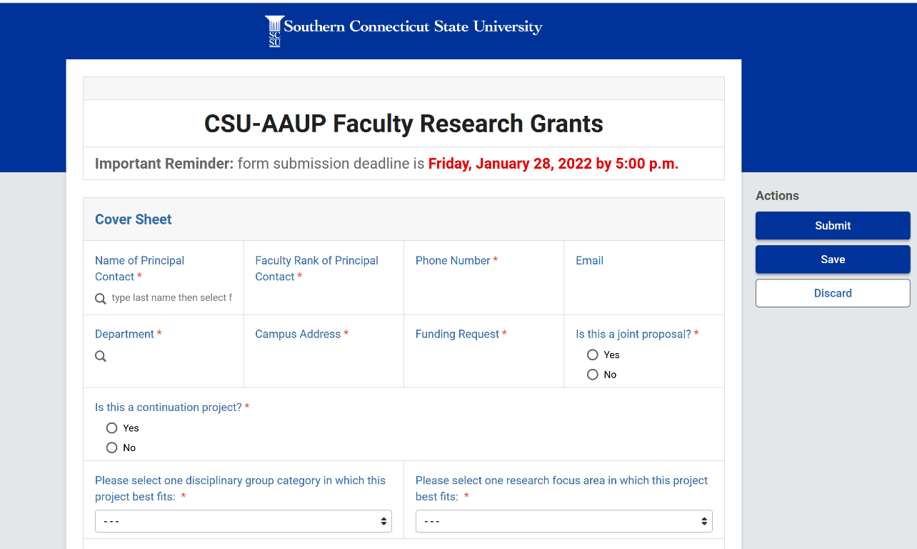
If you select ‘Yes’ in answer to the question ‘Is this a continuation project?’ then the following additional field will appear. Please upload an attachment summarizing results of your previous CSU-AAUP funding.
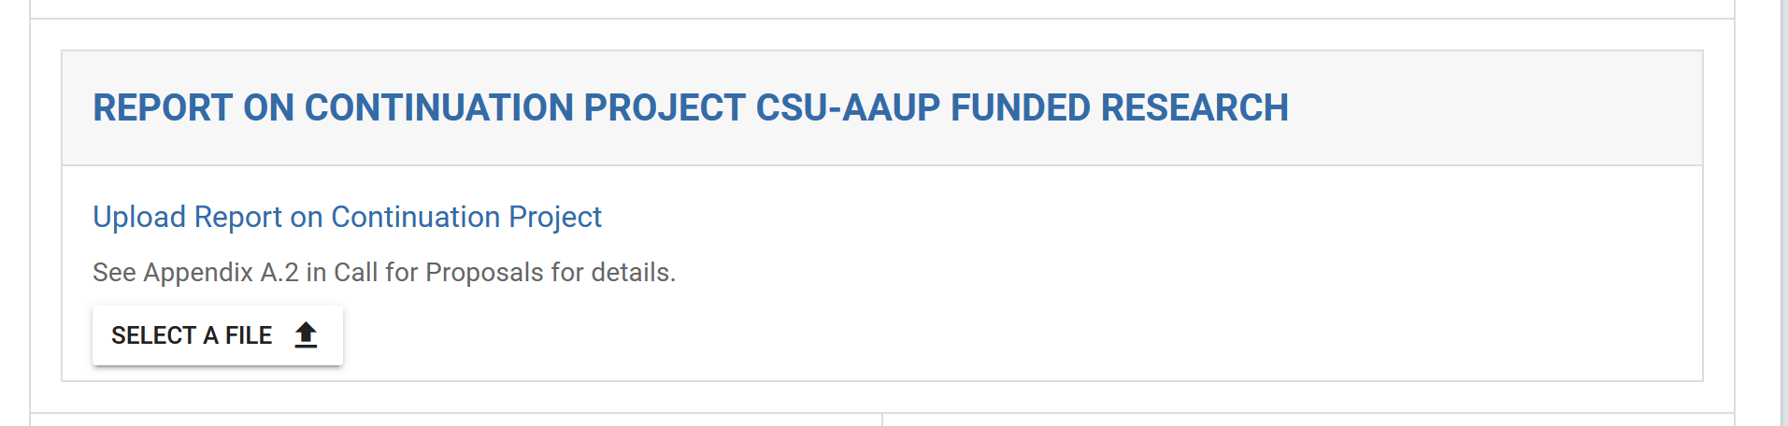

The next section of the form will allow you to enter a title (150 characters maximum) and an abstract (100 words total). Selecting ‘Yes’ to the question ‘Does your research involve human beings as research subjects’ and/or ‘Does your research involve vertebrate animals?’ will cause additional instructions to appear regarding IRB and IACUC policies and institutional points of contact.
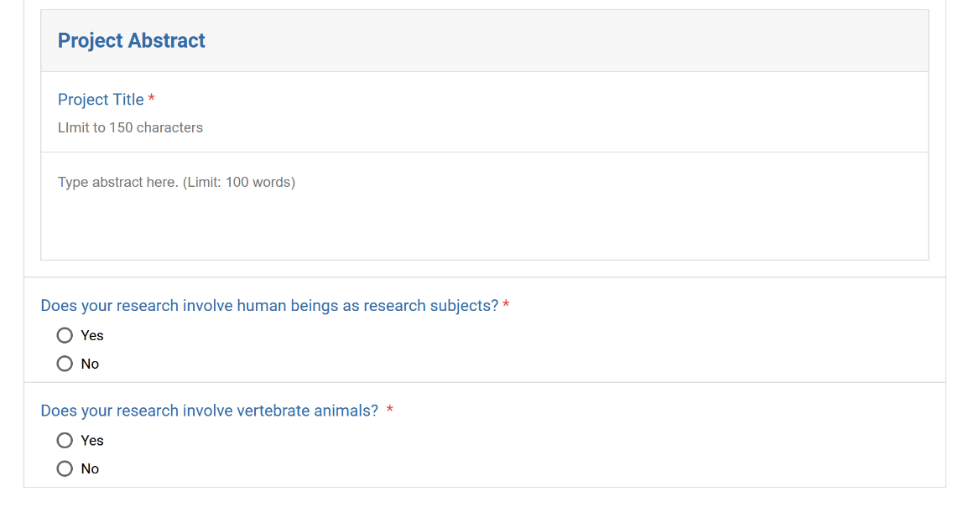
The final section provides a space to upload the CSU-AAUP attachments that are detailed further in the CSU-AAUP funding opportunity announcement: a Budget Form (required), a Proposal Narrative (required), a CV of the Principal Contact (required), and Appendices (optional). A space is also provided for the CVs of optional Co-Proposers. Uploads may be as PDFs, .DOCXs, or .DOCs.
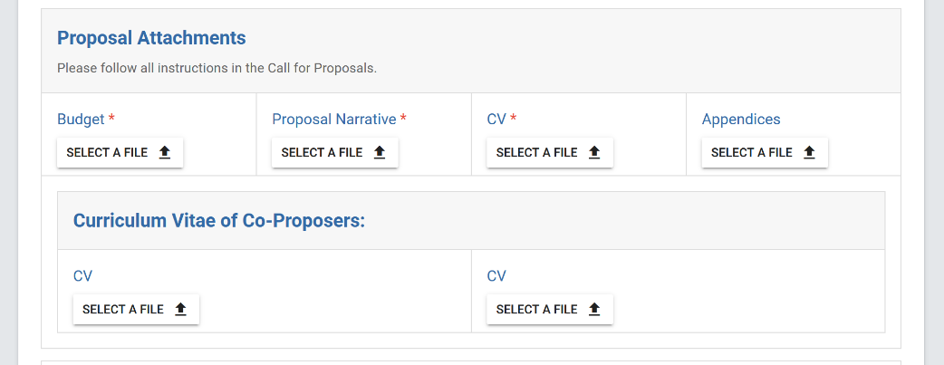
There are several options on the right-hand menu [at the top of the page] when you have finished working on the application:
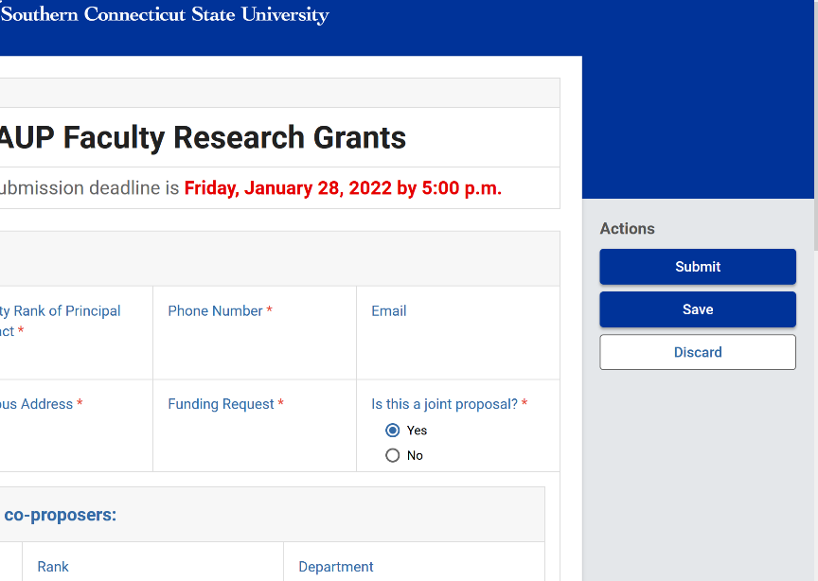

‘Submit’ will send the form and attachments forward to the SCSU Office of Faculty Development for final acceptance and processing. You will receive a notification when this proposal is received and approved, OR if it is incomplete and is denied.
‘Save’ will not submit the form, and a draft will be accessible to you when you visit the Kuali Build Home Page. To return to your drafted applications that have not yet been submitted, please select ‘Submissions.’ There will be a space to select between ‘Submitted’ and ‘Drafts.’
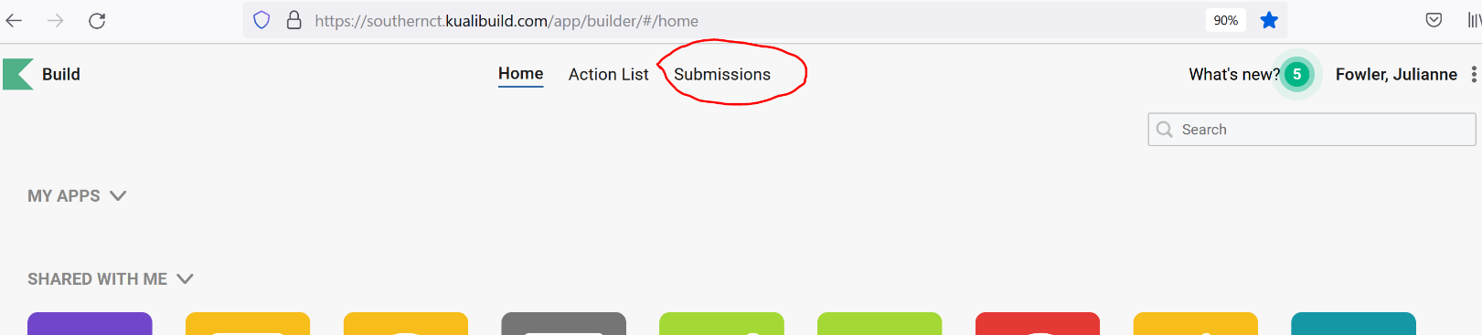
Select ‘Discard’ only if you wish to clear the application form and start over.
NOTE: If you would like to correct an application prior to the January 28, 2022 5:00 PM deadline, please resubmit the application using Kuali Build. In keeping with standard grant practices, the application with the most recent timestamp will be the only application that moves forward for review. Corrections or revisions received after the January 28, 2022 5:00 PM deadline will not be accepted.
- Please contact Jennifer Hudson (hudsonj1@southernct.edu) with questions related to the proposal content and formatting of attachments.
- Please contact Renee Leblanc (leblancr3@southernct.edu) with questions related to technical difficulties or form troubleshooting and copy spar@southernct.edu on your communication.

