**Southern Connecticut**

**State University**

**Search Procedural Guidelines**

Classified

ADMINISTRATIVE RESIDUAL

CLERICAL

MAINTENANCE

PROTECTIVE SERVICES

SKILLED CRAFT WORKER

Southern Connecticut State University is an Affirmative Action/

Equal Employment Opportunity Institution

Revised Fall 2019

**TABLE OF CONTENTS**

Appendices 3

Introduction 4

Recruitment & Selection Overview 4

1. Personal Action Request 5
2. The Search Process 6

Role of ODE/HR in search 6

Search Committee Chair/Committee Members 6

Appointment and Composition of Committee 7

Search Procedures 7

Job Announcement 7

Minimum Qualification 7

1. Preparing to be a Search Committee Member 8
2. Applicant Evaluation Criteria 8

Resume Screening 8

1. Interview Process 10
2. Making the Selection 15

Search Report 15

1. Pre-offer Consultation 15
2. The Job Offer 16

**APPENDICES**

Appendix A Personnel Change Request Form 17

Appendix B Guidelines for Classified Searches 18

Appendix C Search Plan Form 20

Appendix D Affirmative Action Response Card 22

Appendix E Pre-Interview Activities 23

Appendix F Guide to Effective Interviewing 24

Appendix G During the Interview 29

Appendix H Post-Interview Activities 30

Appendix I Search Report Form 31

Appendix J Check List 33

Appendix K Personnel Action Form 35

(currently does not apply for classified positions)

**INTRODUCTION**

**RECRUITMENT & SELECTION OVERVIEW**

The human resources of any organization are its most valuable assets. Fundamental to the development of a quality staff is the recruitment and selection of individual employees. Accordingly, effective recruitment strategies are essential to our goals.

The development of effective recruitment strategies include locating and considering a diverse pool of candidates consisting of people of color, women and members of other protected groups; and matching the candidate's interests, skills, credentials and previous work performance record to a position that will enhance a candidate's potential and will provide continued job satisfaction.

It is the intellectual and moral responsibility, but more importantly, the POLICY of Southern Connecticut State University (SCSU) to advance social justice and equity by exercising affirmative action to remove all discriminatory barriers to equal employment opportunity and upward mobility. Accordingly, SCSU, through its plan of affirmative action, will, with conviction and effort, undertake positively to overcome the present effects of past practices, policies or barriers to equal employment opportunity, and to achieve the full and fair participation of women, Blacks, Hispanics, and any other protected groups found to be underutilized in the work force or adversely impacted by system policies or practices.

Southern Connecticut State University is committed to an aggressive program of equal employment opportunity and affirmative action. The role of affirmative action in each step of the SCSU employment process has been designed in conformance with the Regulations for Affirmative Action by State Government (Sections 46a-68-31 through 46a-68-74) and is detailed in the SCSU Affirmative Action Plan. Clearly, affirmative action and equal employment opportunity are immediate and necessary agency objectives.

At SCSU, a number of individuals and departments work together as a team to facilitate the recruitment and selection of staff in accordance with accepted personnel practices and affirmative action requirements. This team activity includes securing appropriate approvals to initiate and carry out the recruitment effort, and the timely sharing of information so that members of the team may fulfill their assigned responsibilities.

The Office of Diversity and Equity (ODE) is responsible for monitoring all search procedures for the university. This manual will serve as a reference guide to expedite the team’s efforts in the recruitment and selection of personnel.

**I.** **PERSONNEL ACTION REQUEST**

The **appropriate vice president, dean, or director** determines staffing need, checks her/his budget, reviews or creates a job description, fills out the Personnel Change Request Form (Appendix A). The PCRF may be obtained via the human resources webpage. The web address is <https://login.southernct.edu/login/login#/> The PCRF, **along with a organizational chart, draft job announcement and position job description, will be forwarded to the appropriate Vice President, Chief Human Resources Officer, Chief Financial Officer, and President for approval.** Once the PCRF is approved, HR will determine if the request and job description are in conformance with collective bargaining agreements or personnel policies and begin the search process.

All recruitment requests will be handled in accordance with the following guidelines (Appendix B):

The **appropriate vice president, dean, or director** determines there is a personnel need.

A. An action is needed to fill a current/expected vacancy.

1. The **appropriate vice president, dean, or director** reviews the current job description to determine that it still accurately reflects duties and responsibilities; the knowledge, skills and abilities; and the minimum experience and training requirements of the job.

2. If the job description requires revision, the **appropriate vice president, dean, or director** prepares a proposed job description and submits it to HR for review and, if applicable, further processing and approval by the CER and/or affected union.

B. An action is needed to create a new position.

The appropriate vice president, dean, or director submits a proposed job description to HR for review and further processing and approval (possibly the CER or affected union) containing a description of duties and responsibilities; the knowledge, skills and abilities; and the minimum experience and training requirements of the job.

After the necessary signatures have been obtained on the Personnel Change Request Form, the **appropriate vice president, dean, or director** or Search Committee Chairperson completes the Search Plan (Appendix C). The search plan should include the following:

• Duties of the Position

• Minimum Experience & Training & Preferred Qualifications

(education and experience background necessary to qualify for the job -- this will be used to screen resumes in the selection of applicants for interviews.)

• Selection Criteria

(abilities, knowledge, skills and experience necessary to perform the job as of the first day of work -- this will be used to structure the interview of candidates)

• Recommended Salary Range

• Projected Starting Date

**II. THE SEARCH PROCESS**

**Role of the Office of Diversity & Equity and Human Resources in the search process**

The Director of ODE or designated ODE or HR personnel serves as a resource to individual departments and search committees during all phases of the recruitment and hiring process. This assistance includes placing job advertisements; developing recruitment strategies and conducting recruitment; determining appropriate job classifications; providing assistance with development of appropriate referral questions related to the preferred qualifications; ensuring compliance with laws, regulations and collective bargaining agreements; and managing employment benefits. In addition, the Director of ODE or designated ODE or HR personnel encourages, supports and directs cooperative efforts to promote the spirit and intent of affirmative action policy; reviews and approves search efforts for compliance with affirmative action goals and objectives; and works with search committees in a training and consultative role to assist in the search process.

Thesearch committee chairperson and search committee are responsible for establishing and carrying out the search plan. In so doing, they will discuss and establish the following:

• Advertising & Recruitment Sources

• Advertisement Format

• Search Committee Members

• Selection Criteria

• Designated Support Staff from the Hiring Department

**Search Committee Chair /Search Committee**

If the supervisor of the position being searched for, or the supervisor of members of the search committee is on the committee, s/he should take steps to insure that search committee discussions are open and that search committee members are not intimidated or unduly influenced by her/his rank.

The composition of the Search Committee should be as diverse as possible (cross-divisional, cross-disciplinary; racial, ethnic, and gender); while containing sufficient expertise to effectively arrive at a selection decision. Search committees should be diverse. The Director of ODE may recommend the addition of members if s/he deems it appropriate.

Search committee Chairs should have experience with the search process, and review the Search Procedures and the Hiring Process prior to becoming responsible for leading a search. It is the responsibility of the Appropriate vice president, dean, or director to insure that a Chair is familiar with the process, prior to starting a search, by reading the Search Procedures Manual and discussing the process with the appropriate Human Resource professionals.

The ODE office should be contacted to attend the initial search committee meeting. The Director of ODE or designated ODE or HR personnel will meet with the search committee prior to the start of the selection process to outline the affirmative action goals and review recruitment efforts.

**Appointment and Composition of Committee**

The appropriate vice president, dean, or director may appoint either the search committee chair who is charged with selecting the committee members, or both the chair and the entire committee. The composition of the search committee will vary, depending upon the position to be filled and the office, department, school, or college in which the position resides. To insure that equal opportunity interests are observed, the membership of each search committee should include, to the extent possible, at least one woman and one group member from a protected class. In those departments that do no have women or members from a protected group, the appropriate vice president, dean, or director or search committee chair should appoint at least one qualified member from these groups from other departments when feasible. In those cases in which committee members are elected by their department, the appropriate vice president, dean, or director or dean, as the case may be, should appoint a woman and a person from a protected class if no one from these groups is elected. If the committee does not have a woman or a protected class member, it should take steps to ensure representation of these interests. The Minority Recruitment and Retention Committee, (MRRC) is recommended as a resource.

**Search Procedures**

The Chair of the Search Committee coordinates and facilitates the work of the search committee to insure procedural guidelines are followed. This includes such activities as processing all required paperwork accurately and in a timely manner, and working closely with the Director of ODE or designated ODE or HR personnel in all aspects of the search.

**Job Announcement**

When advertising a job opening, the announcement should include: the title of the position; a brief description of duties; the minimum qualifications required to perform the job; the preferred qualifications focused on job related education, experience, skills, competencies and credentials contained within the job classification; the minimum salary; the contact person and address; the closing date for applications or application review date; and the affirmative action/equal employment opportunity statement. Resources for listing advertisements may be found under the ODE website.

**Minimum Qualifications**

It is essential that the announced qualifications required be the minimum necessary to perform the job from the first day of employment. Normally these are found under the Experience and Training requirements section of the job description. Additionally, a statement indicating that “. . . these qualifications may be waived for individuals with appropriate alternate experience . . ." may be added to afford the search committee adequate flexibility. Announcing the job with the minimum qualifications required and the alternate/preferred experience statement will generate the largest possible pool of applicants, thus giving the search committee a greater selection.

The Director of ODE shall review all job advertisements prior to release to verify the absence of discriminatory language, and to insure that they are placed in publications having extensive readership and/or best-suited to targeting protected group or goal candidate audiences in job relevant labor market areas.

**III. PREPARING TO BE A SEARCH COMMITTEE MEMBER**

The purpose of serving as a member of a Search Committee will be to rate each applicant on the basis of a set of job-related factors. This task can be greatly simplified if you follow these few steps:

A. Read the Job Announcement - The job announcement will provide you with a general list of duties which the successful candidate will be expected to perform and the minimum qualifications the successful candidate must possess. This will give you an understanding of both the job duties and the level of skill required of the candidates.

B. Read the Factors Listed on the Rating Form - These are the critical job factors required to do the job. Each factor is an illustration of an identified essential job element.

C. Become Familiar with the Evaluation Criteria - You will be given a rating standard or evaluation criteria with levels of qualifying experience and training defined prior to your review of the resumes.

IV. **APPLICANT EVALUATION CRITERIA**

The criterion by which each candidate is to be evaluated must be job‑related. Therefore, every decision that a Search Committee member makes regarding an applicant's suitability, must be made on the basis of the identified abilities, skills knowledge and experience (ASKE) required to perform the job in question.

The evaluation criteria should normally consist of three (3) to five (5) factors which together make up the abilities, knowledge, skills and experience necessary for successful job performance. Each factor should be weighted based on the relative importance of the identified knowledge, skills and abilities.

**Resume Screening (Sample Process)**

Before the actual evaluation process begins, theDirector of ODE or designated ODE or HR personnel will meet with the Search Committee to go over Affirmative Action goals, the selection criteria, the rating mechanism and the selection of finalists for the interview process.

The rating should begin with a "warm up" session where each Committee member independently rates a small number of resumes and then compares their ratings with the others. Wide discrepancies are discussed, as well as any difficulties experienced in using the procedure, evaluation criteria, etc. Adjustments may be made as appropriate. After completing this stage, Committee members may rate the remaining resumes independently. All resumes must be reviewed on a factor-by-factor basis. Ideally, all resumes should be reviewed against Factor A, then all against Factor B, etc.

Each factor is to be assigned a value from zero (0) to five (5) on the basis of the following rating scale:

(5) High Pass: Applicant's experience and training indicates that s/he clearly possesses the factor at or above the level required for top performance on the job. Candidate's description indicates deep or broad experience and/or training across all areas of the factor.

(3) Pass: Applicant's experience and training indicates that s/he possesses the factor at a level which is satisfactory for the job. Candidate's description shows experience and/or training covering the important areas of the factor.

(1) Low Pass: Applicant's experience and training indicates that s/he possesses the factor at a level which is minimally acceptable for the job. Candidate's description shows experience and/or training which adequately covers the most important aspect of the factor.

(0) No Pass: Applicant's experience and training are below that which would be considered qualifying for this factor. Candidate's background clearly falls below minimum acceptable standards for the job. Applicant's description reveals serious deficiencies in experience and/or training in important areas of the factor, or across the breath of the factor. A rating of zero (0) in a key factor may disqualify a candidate from further consideration.

Upon concluding the application review process, the Search Committee Chair is to present to theappropriate vice president, dean, or director a list of finalists to be interviewed and a list of proposed questions for the interview process. Copies will also be forwarded to the ODE.

To generate the list of finalists Committee members should determine the number of candidates they wish to invite for interviews. While in committee, each member should forward the names of an agreed number of candidates who received the highest individual ratings. Those candidates who have been commonly rated highest by the Committee as a whole shall emerge as the finalists. The Search Committee Chairperson must document the Committee’s good faith effort in cases where they have failed to select a diverse pool of candidates as a finalist**.**

**V. INTERVIEW PROCESS**

Search Committee members must keep in mind during the interview, that the responsibility for a successful interview does not rest entirely on the candidate. Asking the right questions requires as much skill as giving the right answer. To know what questions are appropriate to ask, Committee members must first determine what characteristics are necessary for successful job performance, such as education, experience, initiative, judgment, interpersonal skills, etc. (See Appendices E, F, and G).

Having established these hiring criteria, the search committee, collectively or individually, should proceed to formulate questions that would generate the information needed to evaluate the candidate's qualifications in these areas. The questions must be documented and asked consistently of all candidates. Naturally, follow-up questions may vary with each candidate, but they must always conform to the intent of the original question. Ideally, each Committee member should always ask the same questions of each candidate.

Interview questions must be strictly job related. They must probe the knowledge, skills and abilities identified for successful job performance. Such questions may address not only the specific subject matter as described by the job duties, but also the candidate's education, work ethic, interpersonal skills, initiative, planning and organizational ability and similar personal characteristics necessary for successful performance.

Person-related questions and standards are not only irrelevant in determining the candidate's ability to perform the job, but are prohibited by Federal and State law. You are breaking the law if you question a candidate on any of the following personal matters:

1. Race – There are no job-related considerations that would justify asking an applicant a question based on race.

2. Religion - There are no job-related considerations that would justify asking about religious convictions, unless your organization is a religious institution, which may give preference to individuals of their own religion. Ask no questions about the candidate's social affiliations which may be interpreted as an attempt to determine the candidate's religion.

3. Gender – Generally, there are no appropriate questions based on the applicant's gender during the interview process. Specifically:

(a) Women are no longer protected under state wage/hour laws re: number of hours worked, lifting restrictions, etc.

(b) It is unlawful to deny a female applicant employment because she is pregnant, or planning to have a child at some future date.

(c) Questions on marital status, number of children, child care arrangements, etc. are not appropriate.

(d) Questions as to availability to work should be job-related: What hours can you work? What shift(s) can you work? Can you work on weekends and/or holidays?

4. Sexual Orientation - Under certain state and municipal laws, there are no permissible questions regarding an applicant's sexual orientation.

5. Height and/or weight restrictions – These questions may support gender or national origin discrimination claims unless their relationship to specific job requirements can be demonstrated.

6. Age – You may not ask a candidate their age, nor the age of a spouse or children. Nor may you ask a candidate what year they graduated from college as this may be construed as an attempt at arriving at the candidate's age.

7. Arrest & Conviction Records – Questions relating to an applicant's arrest record are improper, while questions of an applicant's conviction record may be asked, if job related. The Equal Employment Opportunity Commission and many states prohibit use of arrest records for employment decisions because they are inherently biased against applicants in protected classes. The EEOC has issued a Revised Policy Statement covering the use of conviction records by employers in making employment decisions:

(a) The employer must establish a business necessity for use of an applicant's conviction record in its employment decision. In establishing business necessity, the employer must consider three factors to justify use of a conviction record:

(1) Nature and gravity of the offense for which convicted;

(2) Amount of time that has elapsed since the applicant's conviction and/or completion of sentence; and

(3) The nature of the job in question as it relates to the nature of the offense committed.

(b) The EEOC's Revised Policy Statement eliminated the existing requirement that employers consider the applicant's prior employment history along with rehabilitation efforts, if any. The Revised Policy Statement requires that the employer consider job-relatedness of the conviction, plus the lapse of time between the conviction and current job selection process.

8. National Origin – You may not ask an applicant where he/she was born, or where his/her parents were born. You may ask if the applicant is eligible to work in the United States.

9. Financial Status – An interviewer should not ask if the applicant owns or rents a home or car, or if wages have been previously garnished, unless financial considerations for the job in question exist. Any employer who relies on consumer credit reports in its employment process must comply with the Fair Credit Reporting Act of 1970 and the Consumer Credit Reporting Reform Act of 1996.

10. Military Record – You may not ask what type of discharge the applicant received from military service. You may ask whether or not the applicant served in the military, period of service, rank at time of discharge, and type of training and work experience received while in the service.

11. Disability – You may not ask whether or not the applicant has a particular disability. You may only ask whether or not the applicant can perform the duties of the job in question with or without a reasonable accommodation.

Although federal EEO laws do not specifically prohibit any pre-employment questions, the EEOC does look with "extreme disfavor" on questions about age, color, disability, national origin, race, religion, gender or veteran status. Many state fair employment laws do expressly forbid certain types of questions. Following is a representative list of unacceptable and acceptable questions. It is NOT all-inclusive.

|  |  |  |
| --- | --- | --- |
| **TOPIC** | **UNACCEPTABLE** | **ACCEPTABLE** |
| Reliability,  Attendance | -Number of children?  -Who is going to baby-sit?  -What religion are you?  -Do you have pre-school age children at home?  -Do you have a car? | -What hours and days can you work?  -Are there specific times that you cannot work?  -Do you have responsibilities other than work that will interfere with specific job requirements such as traveling? |
| Citizenship/ National Origin | -What is your national origin? -Where are your parents from? -What is your maiden name? | -Are you legally eligible for Employment in the United States? - Same as above -Have you ever worked under a different name? |
| For Reference Checking | -What is your father's surname?  -What are the names of your relatives? | -None -None |
| Arrest and  Conviction | -Have you ever been arrested? | -Have you ever been convicted of a crime? If so, when, where and what was the disposition of the case? |
| Disabilities | -Do you have any job disabilities? | -Can you perform the duties of the job you are applying for? |
| Emergency | -What is the name and address of the relative to be notified in case of an emergency? | -What is the name and address of the person to be notified in case of an emergency? (Request only after the Individual has been employed.) |
| Credit Record | -Do you own your own home?  -Have your wages ever been garnished? -Have you ever declared bankruptcy? | -None -Credit references may be used if in compliance with the Fair Credit Reporting Act of 1970 and the Consumer Credit Reporting Reform Act Of 1996. -None |
| Military Record | -What type of discharge did you receive? | -What type of education, training, Work experience did you receive while in the military? |
| Language | -What is your native language? Inquiry into use of how applicant acquired ability to read, write or speak a foreign language. | -Inquiry into languages applicant speaks and writes fluently. (If the job requires additional languages) |
| Organizations | -List all clubs, societies and lodges to which you belong | -Inquiry into applicant's membership in organizations which the applicant considers relevant to his or her ability to perform job. -Are you a union member? |
| Race or Color | -Complexion or color of skin. Coloring. | -None |
| Worker's Compensation | -Have you ever filed for worker's compensation? -Have you had any prior work injuries? | -None -None |
| Religion or Creed | -Inquiry into applicant's religious denomination, religious affiliations, church, parish, pastor or religious holidays observed. | -None |
| Gender | -Do you wish to be addressed as Mr.?, Mrs.?, Miss?, or Ms.? | -None |
| Addresses | -What was your previous address? -How long did you reside there? -How long have you lived at your current address? -Do you own your own home? | -None -None -None -None |
| Education | -When did you graduate from high school or College? | -Do you have a high school diploma or equivalent? -Do you have a university or college degree? |

WHEN IN DOUBT AS TO THE LEGALITY OF A QUESTION, DON'T ASK IT!

**Vl.** **MAKING THE SELECTION**

While rating the candidates, remember these important things:

Avoid the "Halo" Effect - It is not unusual for a candidate to do well on one factor and poorly on the next. Be careful not to rate a candidate higher or lower on a specific factor based on your impression of their overall qualifications. Keep in mind that simply because an individual has a high level of technical competence, we cannot assume that they have excellent supervisory skills as well.

Avoid Sole Reliance on Crude Indicators of Past Achievements - Such as grades, degrees, job titles, years of experience, and salary progress, to name a few. Such indices when taken in isolation, are minimally useful levels of achievement and accomplishment at best. For example, jobs with the same or similar titles can have quite dissimilar job duties and demands from one organization to another and even within the same organization over time.

You should evaluate candidates based on their specific duties and accomplishments which relate to each factor, not on generalities, satisfactory references when such references have been specified as desirable.

**Search Report**

The Search Committee Chairperson will complete and forward to the Office of Diversity and Equity the Search Report which will include justification of candidates not hired. After the Search Committee has made a selection, ALL search material shall be returned to the ODE by the Search Committee Chairperson (See Appendices H, I, and J). Once the search is completed and the job has been filled, one copy of all search information shall be preserved to comply with record retention requirements. Search materials must be maintained in confidential files and retain in accordance with state record keeping requirements. See Appendix G.

**VII. PRE-OFFER CONSULTATION**

HR to provide language.

**VII. THE JOB OFFER**

The initial offer of an administrative position is made by the appropriate vice president, dean, or director. This offer will normally be verbal to insure that the candidate is interested in the position and in agreement with the terms of the offer. The vice president, dean, or director, then processes the Personnel Action Form (Appendix K) and the Search Report for the appropriate signatures. The ODE must approve prior to final offer being made.

The formal job offer shall be made, in writing, by the President of the university. The offer shall include the employee’s salary, rank, starting date, and details of the employee benefits. This offer is contingent upon a successful background check.

The candidate must sign and return the written offer to conclude the process.

**Appendix A**

The Personnel Change Request Form (PCRF) can be found by loggin into MYSCSU and clicking on “STAFF”. The PCRF form can be found in the Employee automated forms box.

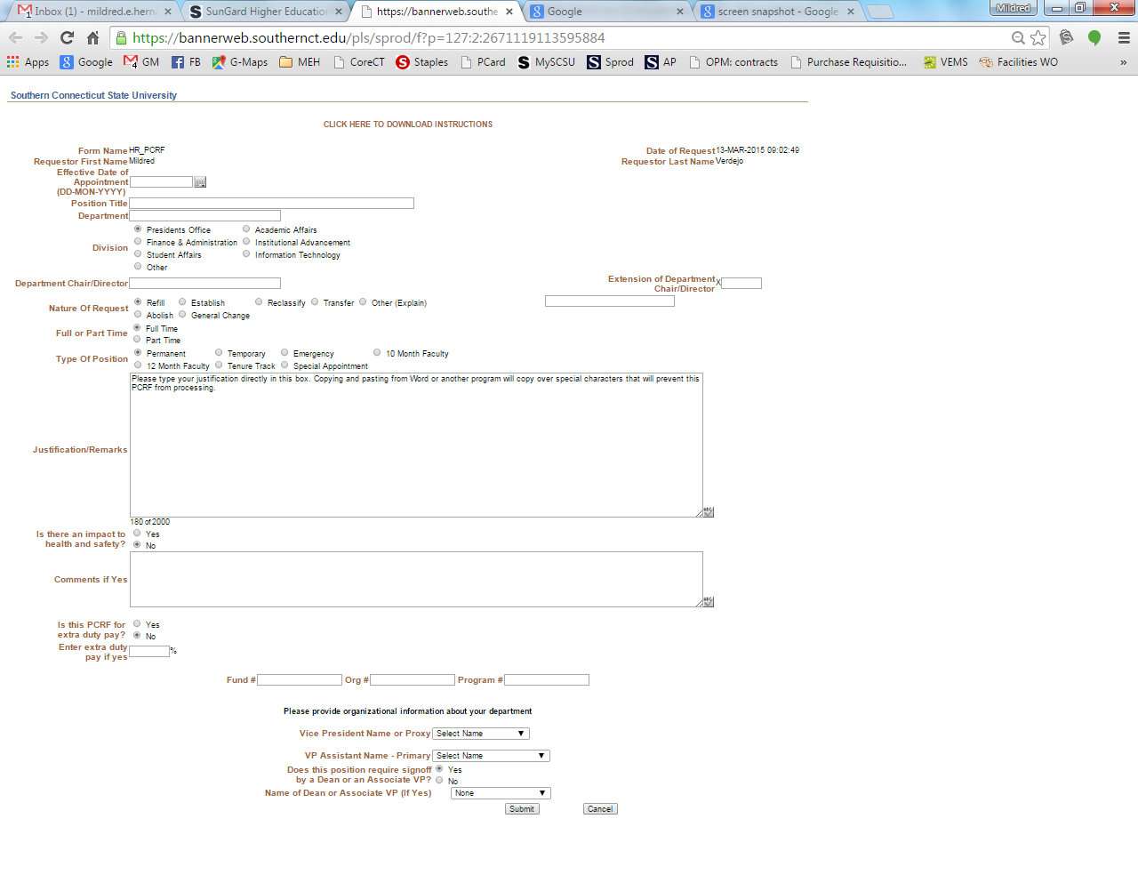

**APPENDIX B**

GUIDELINES FOR CLASSIFIED SEARCHES

The following procedures are designed to ensure a smooth search process and to provide clear documentation of efforts undertaken by all who serve Southern Connecticut State University to support its affirmative action policy and goals. Any additional questions and concerns can be addressed by the Office of Diversity and Equity Programs, ext. 25491.

1. The supervisor shall request the establishment of a position or refilling of a vacancy and shall specify the title of the position (see attached Personnel Change Request Form). If the position refill is approved, Human Resource designee and the supervisor shall form a search committee and complete the appropriate search plan (also attached).

2. The supervisor shall contact the Human Resources designee and discuss recruitment strategies. At that time, it will be determined how the position is to be filled: internal lateral transfer, re-employment list, promotion, certification list, or by advertising.

3. The Human Resources Office staff shall inform the relevant union stewards that a vacancy exits and vacancies shall be posted in the Human Resources Office.

4. Human Resources initiates the certification process by requesting a certification list. Human Resources Office staff shall send letters of interest and application forms to those people whose names appear on the lists. Current application on file may also be considered. The goals of these recruitment efforts is to seek a qualified diverse pool of candidates.

5. Copies of applications received will be forwarded to the search chair for review by the committee. The committee will recommend at least three candidates for interview to the supervisor. The search chair shall seek approval from the Office of Diversity and Equity before the candidates are interviewed.

6. After the interviews have been conducted, the supervisor will prepare a search report, which is to be approved by the Associate Vice President of Human Resources and Diversity and Equity before an offer is made. If the search included certification lists or advertising, the committee shall try to recommend at least three finalists.

7. The Human Resources Office will make a verbal offer to the chosen candidate contingent on background check results. Human Resources will conduct a background check.

8. After background check is cleared, the Human Resources Office staff must clear the recruitment rules with the Department of Administrative Services.

9. After offer is accepted, the Human Resources Office will be responsible for informing the other candidates that the position has been filled.

**APPENDIX C**

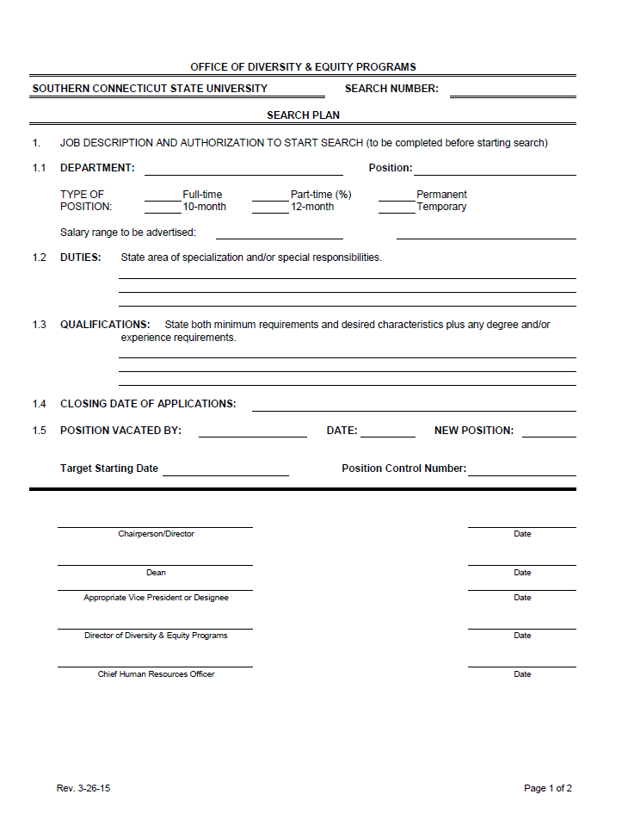

**APPENDIX D**

**AFFIRMATIVE ACTION RESPONSE CARD**

**The Connecticut Department of Administrative Services collects the race and sex of applicants from their master applications.**

**APPENDIX E**

**PRE-INTERVIEW ACTIVITIES**

**Scheduling**

• Allow sufficient time for your interviews. If you have scheduled them "back-to-back", allow at least 15 minutes between appointments.

**Environment**

• Set up a quiet, interruption-free interview space. Have someone hold your calls. Eliminate distractions.

• Position the chairs appropriately. You should face the candidate and be able to observe facial expressions and hand/body gestures.

• Have "marketing materials" readily available, e.g., the SCSU Fact Book, about Southern, Department organizational chart, university materials.

• Applicants who inform you that they are disabled or physically challenged may require facility accommodations to attend the interview. Accommodate them. Call the Ex. Asst. President/Director of ODE if there are questions about making accommodations.

**Preparing**

• Ensure that each interviewer is assigned different questions to ask the candidates.

• Read the resume and/or application. Identify potential red flags -- gaps in employment, length of time in each position, progression of increasing responsibility with job changes, etc.

**APPENDIX F**

**GUIDE TO EFFECTIVE INTERVIEWING**

**Analytical Ability**

Definition:

• Ability to separate data and information into elemental parts and to arrive at the nearest appropriate conclusion.

• Identifies problems and opportunities effectively and efficiently.

• Gets beneath the superficial considerations when evaluating a complex issue.

• Can recognize the pros and cons of an issue or approach.

• Displays confidence in own abilities and ideas.

Sample Interview Questions:

1. What are the advantages and disadvantages of [a job related issue about which the candidates should be knowledgeable]?

2. What do you think about [a job related issue]?

**Educational Preparation**

Definition:

• Success Orientation

• Leadership Roles

• Motivators

• Time Management Skills

Sample Interview Questions:

1. Tell me about your educational background. What influenced your educational goals? What has held you back from attaining your educational goals?

2. What are your plans for additional education?

**Work Ethic**

Definition:

• Stable Work History

• Motivators

• Performance Record

• References

Sample Interview Questions:

1. Tell me about your work history - the jobs you have held, the duties and responsibilities, and your reasons for leaving. Under what condition did you leave?

2. What did you like and dislike about each job?

3. What comments will the supervisors have about your performance? About your attendance? About your ability to get along with co-workers?

4. What would you do if you are offered a job which sounded exciting and challenging, but which is not a promotional opportunity? Why?

**Judgment/Decision Making Skills**

Definition:

• Comfortable with making decisions; does not avoid them.

• Knows when more facts are needed vs. having enough facts to make a sound decision.

Sample Interview Questions:

1. What process or specific steps do you take in making an important decision? What are they?

2. Tell me about the most difficult decision that you have made recently. Why was it difficult? On what basis did you make the decision?

3. What kind of decisions do you put off making?

4. Have you made any decisions that you wish now you had made differently? What went wrong?

**High Initiative/Goal Orientation**

Definition:

• Demonstrated initiative in their work and/or school experiences.

• Sets and accomplishes goals.

• Persistent in the pursuit of goals; does not discourage easily; rebounds rapidly from frustration and defeat.

Sample Interview Questions:

1. How have you shown initiative in your present job? What projects or activities have you initiated?

2. Tell me about the goals you have set for yourself.

3. Tell me about the most difficult goal that you have accomplished. What obstacles did you overcome to accomplish it?

4. What goals have you given up on?

**Planning & Organizing**

Definition:

• Plans and organizes complex tasks and work load adequately to accomplish them in a reasonable time and with reasonable results.

• Effectively plans the activities of their present job.

• Effectively organizes their individual work station, travel plans, etc.

Sample Interview Questions:

1. How do you plan your daily activities? Let's talk about your daily work routine. What tasks are high priority? What tasks are low priority?

2. How do you manage your time?

3. What is the most complex project you have ever worked on? How did you plan and organize that project?

**Interpersonal Skills**

Definition:

• Relates well to superiors, peers subordinates, customers, etc.

• Is tolerant and understanding of others.

• Accepts others; is not highly opinionated on the behavior of others; does not frequently put others down.

• Deals productively with people who are “difficult”, who have poor relationship skills.

• Does not create conflicts in his/her interpersonal relationships.

Sample Interview Questions:

1. Tell me about the most difficult person you have had to deal with. How did you handle him/her? How successful were you in dealing with him/her?

2. How frequently do you have to deal with someone that you really dislike? How do you do it? With what degree of success?

**Comfort With Pressure**

Definition:

• Deals effectively with pressure and stress on the job; is productive in a pressured environment.

• Has performed effectively in a pressured environment.

• Is confident of his/her ability to produce in a pressured environment.

• Does not mind, or even prefers, working in a pressured environment.

Sample Interview Questions:

1. What things cause pressure in your present job/present schedule? How do you handle it?

2. What is your usual response to stress?

3. Tell me about the strategies that you use to deal with stress.

4. Tell me about the impact stress has on your ability to perform. Give me examples.

**Verbal Communication**

Definition:

While reflecting on the interview, did the candidate:

• State facts in a logical manner?

• Express self effectively?

• Listen carefully?

• Speak when appropriate?

• Maintain good eye contact?

• Use appropriate grammar and vocabulary?

• Speak in an understandable manner?

• Understand and respond appropriately?

• Convey a sense of sincerity and honesty?

**APPENDIX G**

**DURING THE INTERVIEW**

• Establish rapport with the candidate. However, be careful of allowing "small talk" to go beyond relevant or appropriate issues.

• Listen! The interviewer/candidate speaking ratio should be 40/60 or 30/70.

• Maintain eye contact with the candidate.

• Tell the applicant you plan to take notes during the interview. Notes should be made in your own shorthand.

• Discuss company policies, re: parking, smoking, hours of work, and related policies or

practices.

• Questions asked of disabled or physically challenged individuals should be the same as asked of those who are physically able. You may ask candidates if there are any circumstances which would prevent them from performing the job effectively. You should ask this of all candidates if you ask any one candidate.

• Ask the following types of questions:

Open ended

Reference

Assumption

Probing

Review (performance)

Experience

• All communication with the candidate should be objective and job related.

• Ask them for any questions they might have. Make note of particularly analytical or probing questions, or indications that the candidate has truly done his/her homework in preparing for the interview.

• Conclude the interview on a positive note. Keep in mind that this may be the candidate that you want to attract.

• Inform the applicant when to expect notification.

**APPENDIX H**

**POST-INTERVIEW ACTIVITIES**

• Evaluate the interview results. Meet to discuss impressions and compare notes.

• Select the top two or three candidates. Rank them. Review any training needs required for candidates, particularly candidate number two and three.

• Check references!

* Ask the Hiring Department designated Search Committee support staff to send correspondence indicating "no interest" to all candidates not selected for further consideration.

• Correspondence indicating "no interest" for candidates two and three should be deferred until after candidate one has accepted the verbal offer, and indicated a start date. (We may even want to wait until the candidate actually resigns from their current job before rejecting candidate two and three. Rely on instincts!)

• Verbal offer will be made by the Appropriate vice president, dean, or director to the candidate selected indicating that the offer is contingent upon satisfactory background check.

* If references are not satisfactory, decide to either probe further with additional references, or to reject this candidate. This will obviously depend upon the quality of the reference and the nature of the position for which the candidate is being considered. It may also depend upon what you have already learned about the candidate during your interview and may not change your opinion of the candidate.

**APPENDIX I**

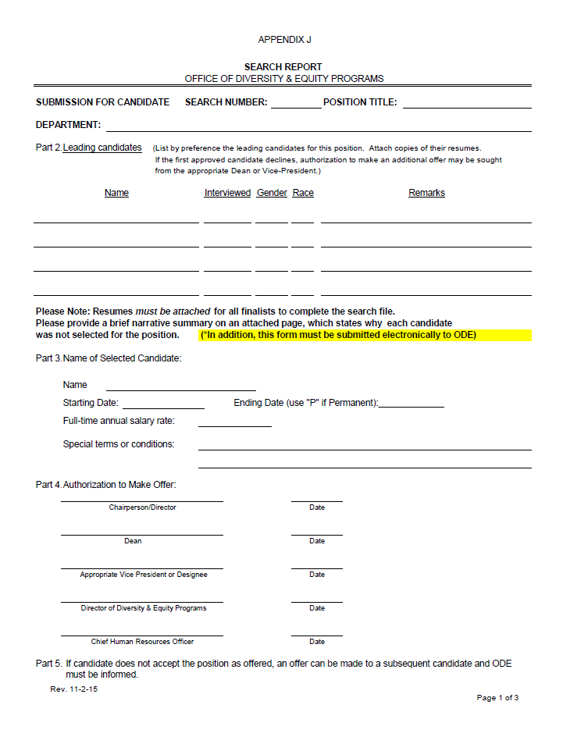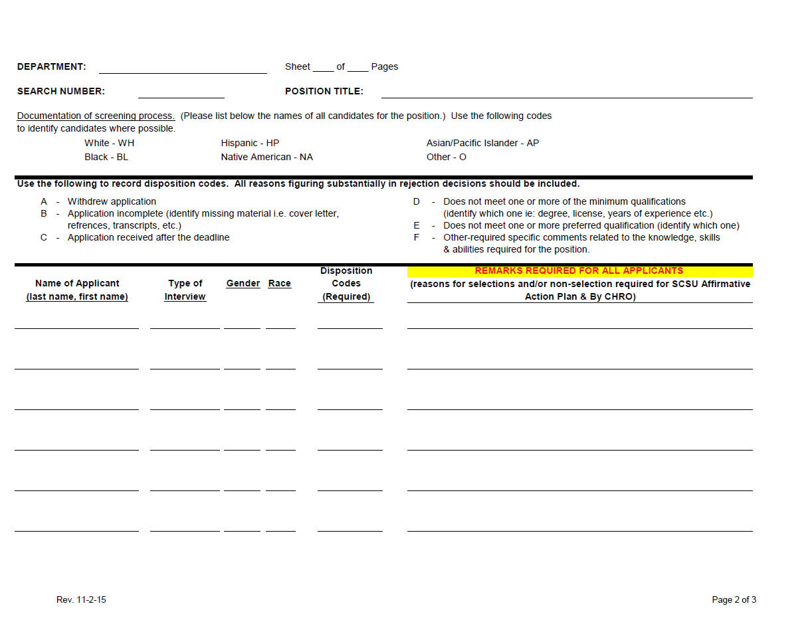

# appendix J

# SEARCH CHECKLIST

The following checklist indicates the materials necessary for the completion of Affirmative Action searches for full time positions. The Office of Diversity and Equity audits all university searches.

**Step I. Initiating a Search** - The Personnel Change Request Form (PCRF) initiates the search process.  Once you obtain the appropriate signatures on the PCRF, contact the Office of Diversity and Equity (ODE) to obtain a search number.  The search chair or his designee may do this via email, fax, or itner-office mail.  Additionally, the search plan and advertisement copy will be sent to the ODE after the appropriate signatures have been obtained.  The original plan will be forwarded to Human Resources unless otherwise directed.

a.  Personnel Change Request Form (PCRF) [ ]            completed ________

b.  Complete Affirmative Action Search Plan [ ]            completed ________

c.  Copy of the Advertisement is included with plan [ ]  completed ________

**Step II.  Recruitment Strategies -** Please contact the ODE Office via email to schedule a meeting to go over the affirmative action search procedures, recruitment strategies (as applicable) and candidate selection criteria once the Search Plan has been approved.  A representative from the Office of Diversity and Equity (ODE) or Human Resources will attend the initial search meeting.  After this meeting, the search chair or Human Resources designee will submit the following documents once developed via email to the ODE representative prior to scheduling interviews.

a. Copy of the core interview questions [ ]             completed_________

b. Candidate selection criteria grid(s) [ ]                completed_________

c. Proposed interview schedule [ ]                         completed _________

d. Proposed list of candidates [ ]                            completed _________

**Step III. Demographics of Applicants:**  Completed affirmative action response cards or PLD-1 applications are voluntarily sent to Human Resources by applicants.  This information is used to determine what the applicant pool is like and will be compared to the proposed list of candidates sent to ODE in Step II of the process.

a. Acknowledgement cards sent or PLD-1 [ ]                        completed_________

**Step IV. Interview Process:** The following items should be submitted by the search committee chair/ Human Resources designee for approval by the ODE prior to scheduling on campus interviews:

a. List of selected candidates [ ]                            completed _________

b. Schedule for on campus interviews [ ]                completed_________

c. Copies of the resumes and letters of reference for each candidate being interviewed (may be requested) by the Office of Diversity & Equity at this period.

d. Completed selection criteria grid [ ]                   completed________

This grid may be used to identify interview candidates.

**Step V. Search Conclusion/Search Report:** A Search Report is required prior to hire. The following items should be submitted to ODE at the conclusion of the Search. This report must be completed in detail.  The codes may be used and should be consistent with the selection grid.  Further justification may be requested for searches that do not meet affirmative action goals.  Written justification will also be required when recommending unranked finalist for consideration.

a. Search Report  [ ]                                             completed________

b. Unranked recommended finalists [ ]                     completed_______

c. Completed selection criteria grid* [ ]                     completed________

*Note: This grid may be different from the interview selection grid and identifies criteria used to identify the successful candidate.

**Step VI. Job Offer -** A job offer made not be made without the approval of the appropriate parties.

a. Human Resources makes the job offer [ ]   Received______

b. Background check [ ]                                       Completed_____

c. Offer made by appropriate personnel [ ]            Date of offer _________

Candidates that were interviewed and not selected should receive a letter indicating search has been closed and that a successful candidate has been chosen.  Internal applicants should be notified of the search outcome in accordance with collective bargaining agreements.

Sample copies of all correspondence to candidates, memos regarding the search, reference check information, etc. should be available to the ODE upon request.

