
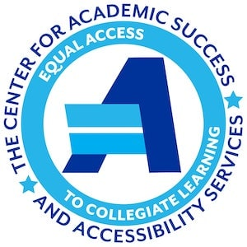

Accommodations 1-2-3: Easy Guide for Students

Is this YOU?
- Had an IEP (for special education) or a 504 Plan in high school?
- Have a disability or other diagnosed condition?
- Received accommodations at another college?
- Are an English language learner?
- Are pregnant or experiencing related conditions?
You may be eligible for academic accommodations – class and testing adjustments to help remove barriers so students can fully access their education – at Southern. Get started now!

Step 1 – Register with CASAS

Fill out the intake form on our website using your SCSU email
- Visit us in Buley 303
- Email us at casas@southernct.edu
- Call us at (203) 392-6828

Step 2 – Gather and submit your documentation

- IEP (for Special Education)? – Last grade IEP plus last school evaluations (i.e., cognitive, academic achievement, etc.)
- 504 Plan? – Last 504 Plan plus documentation from your medical provider or therapist (e.g., our Academic Accommodation Provider Form, evaluations, reports or letter on provider letterhead)

Want help getting your high school records?
Complete, sign (by hand), and return our Release of Records form!

- Accommodations at another college? – Most recent accommodation letter plus documentation you submitted to that institution
- Something else? – Documentation from your medical provider or therapist (e.g., our Academic Accommodation Provider Form, evaluations, reports or letter on provider letterhead)

To submit:
- Attach to the bottom of the online registration form
- Upload through the Accommodate portal
- Email: casas@southernct.edu
- Fax: (203) 392-6829
- Drop off at CASAS in a sealed envelope labeled “For Accessibility Services Staff”

Step 3 – Schedule an intake meeting by:
- Opening Accommodate, selecting “Appointment” then “Request New Appointment”
- Calling us at (203) 392-6828
- Visiting us at Buley 303

Important! Accommodations are effective only after CASAS approves them and notifies your professors; they are not retroactive. So don’t delay!

Questions? Contact CASAS:

Phone: (203) 392-6828

Office: Buley Library 303

Email: casas@southernct.edu

Visit: https://inside.southernct.edu/casas/accessibility-services

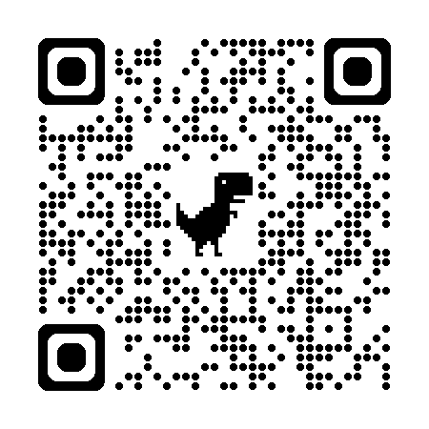
Scan:

