SCSU - Quick Reference Guide
Kuali Proposal Approval Process
It is recommended that electronic approvals be initiated 3 – 5 business days in advance of a proposal’s posted or requested deadline. Please plan and coordinate with SPAR staff accordingly.

This process is entirely internal and separate from the external submission to a sponsor; approving a proposal in Kuali Research does not automatically submit it or advance it to the sponsor for review.

- Receive email notification to certify as a PI or Co-I [five questions related to research compliance and avoiding conflicts of interest]. All proposal team members must respond to these questions before a proposal can advance to the internal electronic approval stage.

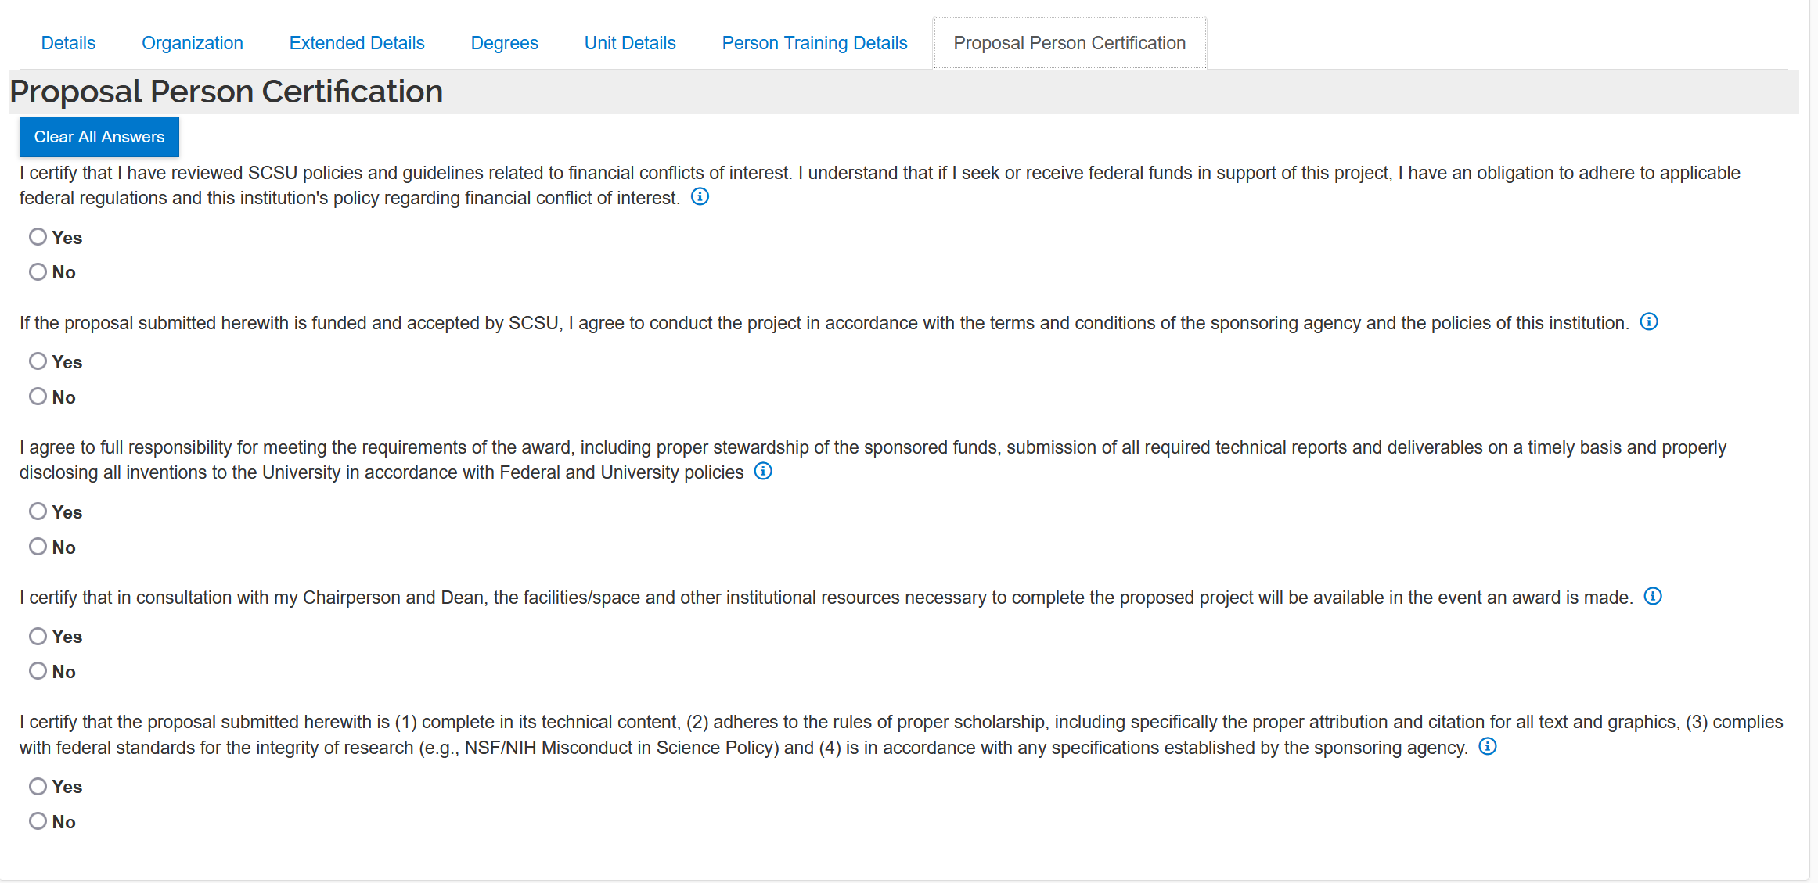

- Proposal is entered into internal approval routing by SPAR staff

- Receive email notification to review and approve a proposal with a link to the eDoc – follow the first weblink that appears in your automated email

- The link takes you to the Kuali Research website; login using your SCSU login and password if you are not already signed in.

  - Note: if you cannot locate the approval request in your email, go to https://southernct.kuali.co/dashboard/ and look for “Proposals routing to me” in the top left-hand section of the screen

- The proposal summary page opens; menu navigation is on the left and tabs to the proposal detail sections display in a row through the middle of the screen. Navigate through the tabs to review all the proposal details and attachments.

- Action buttons are on the bottom of the screen. After review of the proposal information, click the ‘Approve’ button. If you have software navigation questions or cannot approve the proposal, please call SPAR (203-392-6800) and speak to the pre-award staff or email spar@southernct.edu. For specific project activity questions, please contact the proposal’s Principal Investigator.

- If you have more than one approval role (for example, you are the PI and the chairperson of the department) a statement appears: Do you want to receive future notifications?

  - Yes - > you must repeat the same approval steps in the second role
  - No - > you are approving for both roles with the single approval step

- You may receive a warning notification about file titles; please disregard this notice. It does not apply to the processes used at SCSU

- Once the proposal is approved, the screen returns to the proposal summary page. Close the proposal and log out of Kuali Research.

- If there is more than one Co-PI, the proposal will remain within your “Proposals routing to me” view until all of your team members have completed their approvals.

Proposal Submission Route Map

