**IS IT A RECORD??**

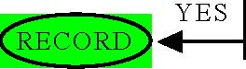

Did you generate or receive the information to use for your technical and/or administrative work in conducting State business?

**IS IT A RECORD??**









Is it an original document related to State business that does not exist elsewhere?

Does it document business actions, such as: what happened, what was decided, what advice was given, who was involved, when it happened, the order of events and decisions?

Does it fulfill regulatory recordkeeping requirements specific to your programmatic work?

Does it contain information that is evidence of your agency’s functions, policies, decisions, procedures, operations, mission, programs, projects, or activities of the State?

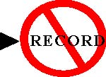









Is it information accumulated and maintained at the workplace, but which does not affect or reflect the transaction of State business?

Is it junk mail or documentation that has no work-related information or evidentiary value?

Is it a copy of a document or correspondence kept only for convenience or reference on which no action is taken?

Is it published and/or otherwise processed information that you received and use as a reference?

**NO**

Is it an uncirculated draft or interim document that does not contain substantive comments for which there is a final version being maintained?