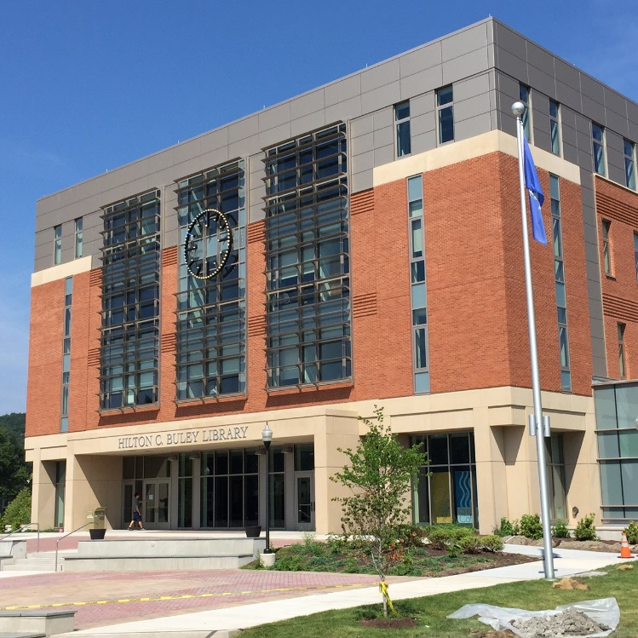

Master of Library and Information Science

  - Degree portfolio
[Your Name Here] | Southern Connecticut State University | [Month/Year]

MLIS Student Goals and Learning Outcomes
List of Courses Completed to Fulfill MLIS Degree
Capstone Experience
Reflection on Student Learning Outcomes
Personal Goals and Professional Development Plan
Resume

MLIS Student Goals and Learning Outcomes

List of Courses Completed to Fulfill MLIS Degree

Capstone Experience

Insert Special Project or Thesis (text document only, no links)

Reflection on Student Learning Outcomes

Personal Goals and Professional Development Plan

Resume

