Faculty Quick Guide

Your Responsibilities:
The faculty workload verification process has begun. You will need to access Digital Measures’ Activity Insight (DMAI) in order to verify your data for the current semester.

Getting Started:
- Go to the office of Assessment and Planning on the SCSU website:
https://www.southernct.edu/assessment-and-planning/
- Within the yellow box on the left side of the screen, click Faculty Workload, which is the second tab from the bottom.
- Login to DMAI using your university username and password.
Once logged in, you will need to focus on the items in the red box below: A. Teaching Workload, B. Non-Teaching Workload (Reassigned time, Sabbatical), and C. Credit Load History and Remainder.
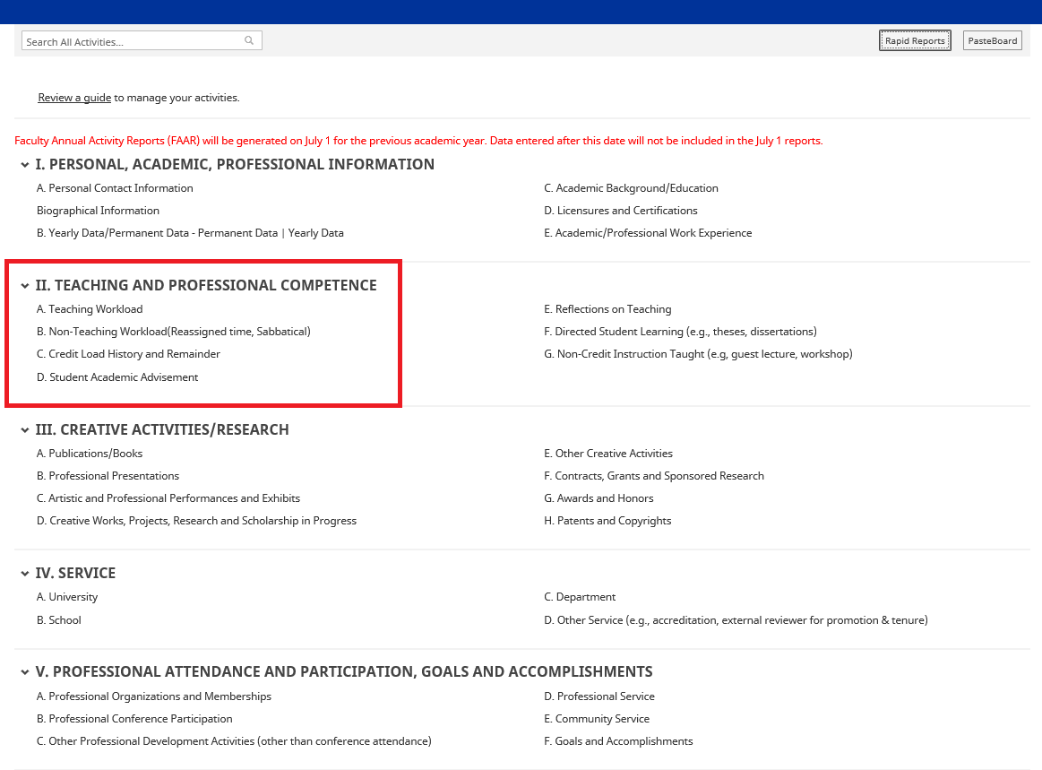

A. Teaching Workload
Click on A. Teaching Workload. You will be directed to a screen where there is a list of courses you have taught in the past and are teaching for the current semester. Please review each course in the Spring 2020 semester only. Here is an example of what you will see:
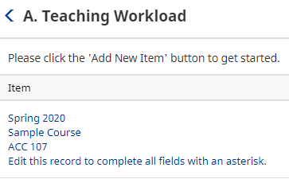
The information from each one of these courses has been imported directly from BannerWeb. You will need to click on each course labeled “Spring 2020” and verify that the number of Faculty Load Credits is correct.
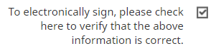
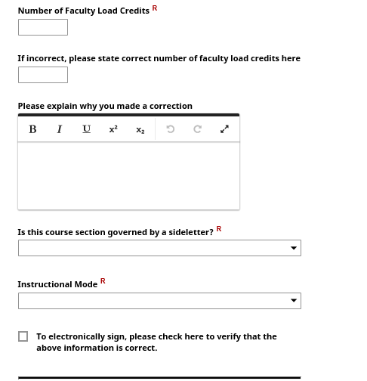

If correct, please electronically sign in the designated box.
Click Save in the top right hand corner. You will then be redirected back to the Teaching Workload screen. You must verify and sign off on every course for the Spring 2020 semester.

DO NOT ATTEMPT TO MAKE ANY CHANGES/CORRECTIONS IN THE NUMBER OF FACULTY LOAD CREDITS YOURSELF. Any missing data or discrepancies in the number of Faculty Load Credits should be reported to your department chair.

B. Non-Teaching Workload
Navigate back to the main Activity screen by clicking the black arrow shown below:
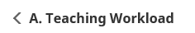
Under II. TEACHING AND PROFESSIONAL COMPETENCE, click on B. Non-Teaching Workload (Reassigned time, Sabbatical).

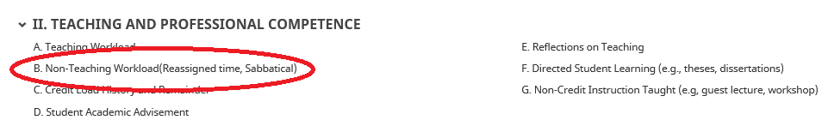

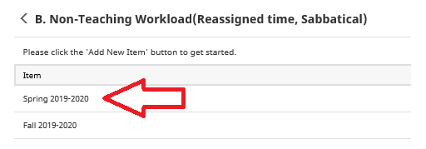
Next, click on Spring 2019-2020 and you will be taken to the record. Please review all the information for accuracy, and then electronically sign that the above information is correct by checking off the electronic signature box. Remember to click Save in the upper right-hand corner.

PLEASE DO NOT ATTEMPT TO MAKE ANY CHANGES/CORRECTIONS TO ‘TYPE OF NON-TEACHING WORKLOAD CREDIT’ (reassigned time) or ‘CREDITS PER SEMESTER’. If there are errors, please see your department chair.
For faculty who do not have an item listed for Spring 2019-2020, please click +Add New Item which is located in the upper right-hand corner. Here you will be directed to a screen that looks like this:
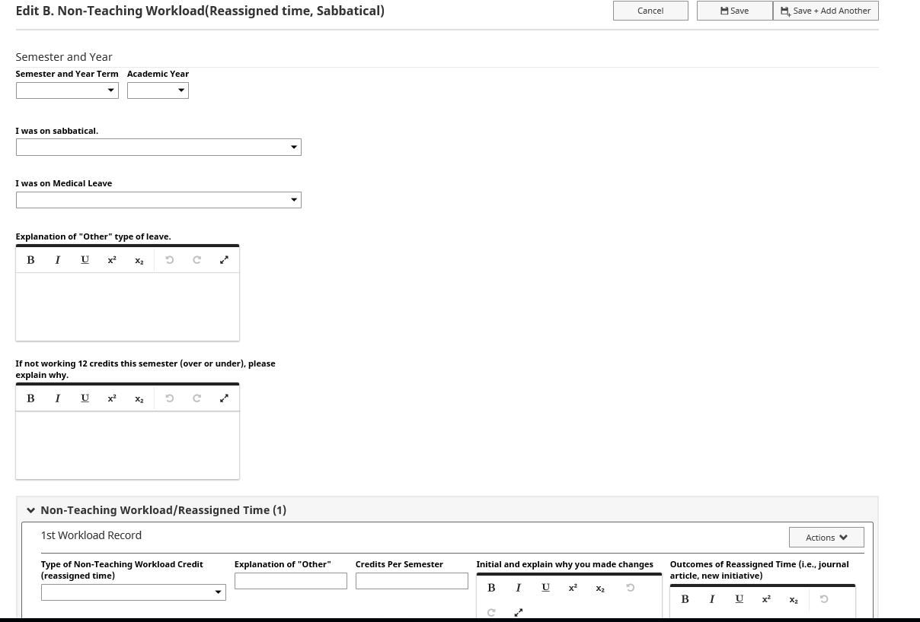
Enter the current semester and year, and then enter the information into the next two boxes only. Next, scroll down to the bottom of the page to electronically sign the box. This indicates that the above information is true and that you have no reassigned time for the Spring 2020 semester. Please be sure to click Save in the upper right-hand corner.
If you feel that you do have reassigned time that is not appearing, please see your department chair. DO NOT FILL IN ANY INFORMATION INTO THE ‘TYPE OF NON-TEACHING WORKLOAD CREDIT’ (reassigned time) or ‘CREDITS PER SEMESTER’ WORKLOAD RECORD SECTION.

C. Credit Load History and Remainder
Under II. TEACHING AND PROFESSIONAL COMPETENCE, click C. Credit Load History and Remainder. You will be redirected to a screen that looks like this:
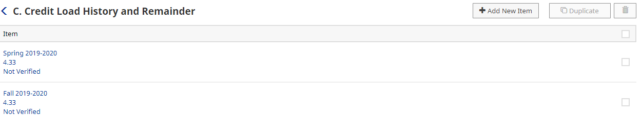

Click the current semester and view your Accrued Workload Remainder. If it is correct, please check the box to electronically sign off on it. If it is inaccurate, please contact your department chair. Please be sure to click Save once you have electronically signed the box as shown below:
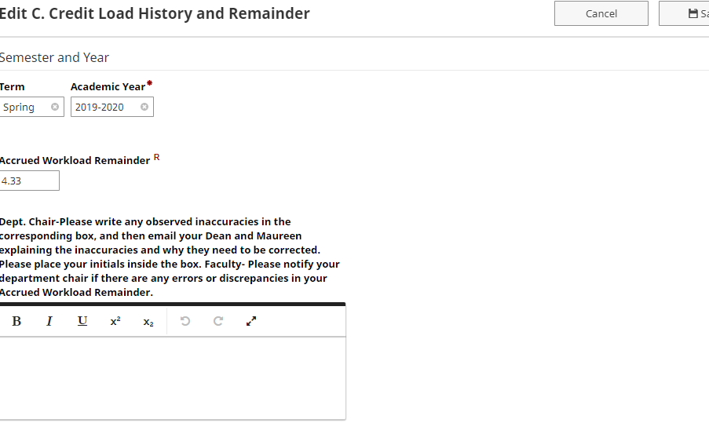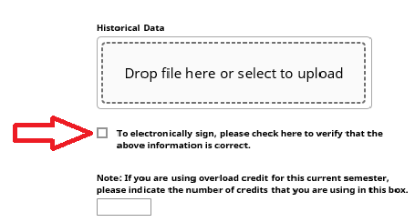
If there is an error or discrepancy in your current accrued workload remainder, please notify your department chair.

