Chair Quick Guide

Your Responsibilities:
The faculty workload verification process for spring 2020 has begun. You should have received your FT Faculty Workload Summary Report-Spring 2020 for your department. If you did not, please contact Maureen at gilbriderem1@southernct.edu. You will need to review the information in this report, ensuring the accuracy of each faculty member’s faculty load credits, reassigned credits, and accrued workload remainder. This report reflects the data contained within the online system Digital Measures’ Activity Insight (DMAI). Only if you find errors or missing data in the FT Faculty Workload Summary Report-Spring 2020 for a particular faculty member in your department, will you need to login to DMAI to make the necessary changes for that faculty member. Again, you do not need to go into DMAI and check every faculty member’s data; do this step (and the following) only if you find an error in your Faculty Workload Summary Report, Spring 2020.

Getting Started:
- Go to the office of Assessment and Planning on the SCSU website:
https://www.southernct.edu/assessment-and-planning/
- Within the yellow box on the left side of the screen, click Faculty Workload, which is the second tab from the bottom.
- Login to DMAI using your university username and password.

Once you have logged in, you will be directed to the page where you can manage your own data. As a chair, you have been given access to modify other faculty members’ data within your department. To manage their data, click on Activities on the top toolbar, then click Manage Data. Then select the relevant faculty member’s name under the “User” drop down menu. Click Continue to be redirected to that faculty member’s data. Focus on information underneath the header “Teaching and Professional Competence” to edit data in screens A, B, and C.
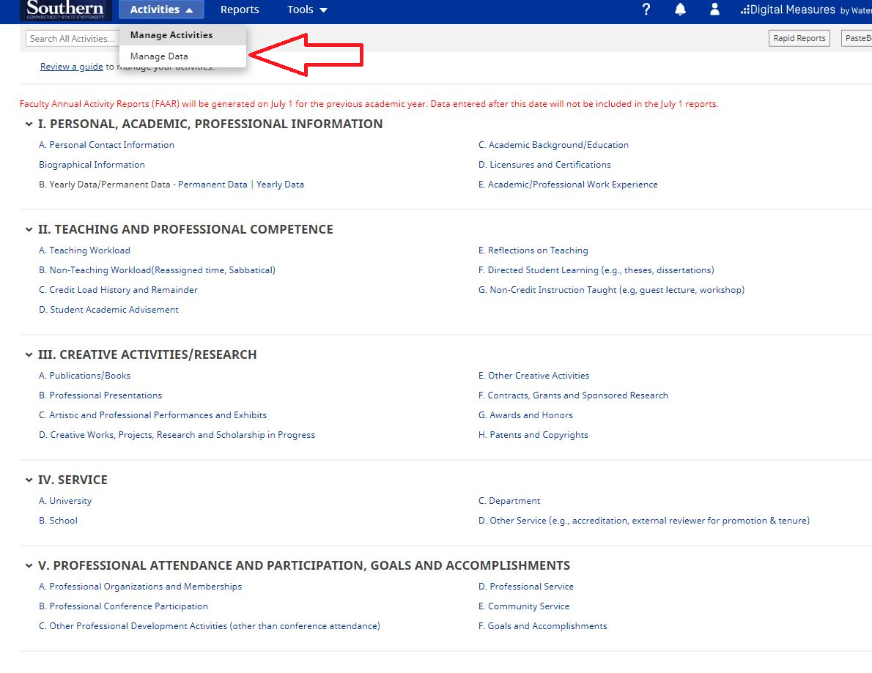

A. Teaching Workload:
Please click on A. Teaching Workload to begin editing data for the faculty member who had errors in the report. You will be directed to a screen that lists each course they are teaching and have taught. Please review the number of Faculty Load Credits for each course within the Spring 2020 semester only. You may navigate back to the previous screen by clicking the arrow next to “A. Teaching Workload.” You will need to go through every single course in order to find any errors for that faculty member. See below for an example:
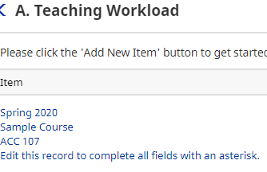
When you click on a course, you will be directed to that course’s detailed information. The information within is imported directly from BannerWeb. To change the load credits, enter the correct information into the box labeled “If incorrect, please state the correct number of faculty load credits here” and provide an explanation in the box below that. You must put your initials next to your explanation. Once you have finished with that course, click Save in the upper right-hand corner, then check all other spring 2020 courses for errors.
Note: If a course does not exist within DMAI, you will need to contact Maureen so that she can add that information. Do not attempt to add this information yourself. Please provide Maureen (gilbridrem1@southernct.edu) with the following information so she may add the course:
- Course Name
- Course Prefix and Course Number
- Section Number
- CRN Number
- Official Enrollment Number
- Number of Student’s Academic Credit Hours
- Faculty Load Credits
- Is course governed by a side letter? Yes or No.
- Instructional Mode
The faculty member will be notified when the course is added so that they may go in and electronically sign off on their information.
Once you have verified all the information within “A. Teaching Workload”, click B. Non-Teaching Workload (Reassigned time, Sabbatical).

B. Non-Teaching Workload
You are only checking the current semester, so click Spring 2019-2020. Once inside the record, please check to make sure that the information in “Type of Non-Teaching Workload Credit (reassigned time)” and “Credits Per Semester” are accurate. When you find an error, you will need to make changes in the appropriate box, and then initial and explain why you made changes. Please be sure to click Save in the upper right-hand corner.
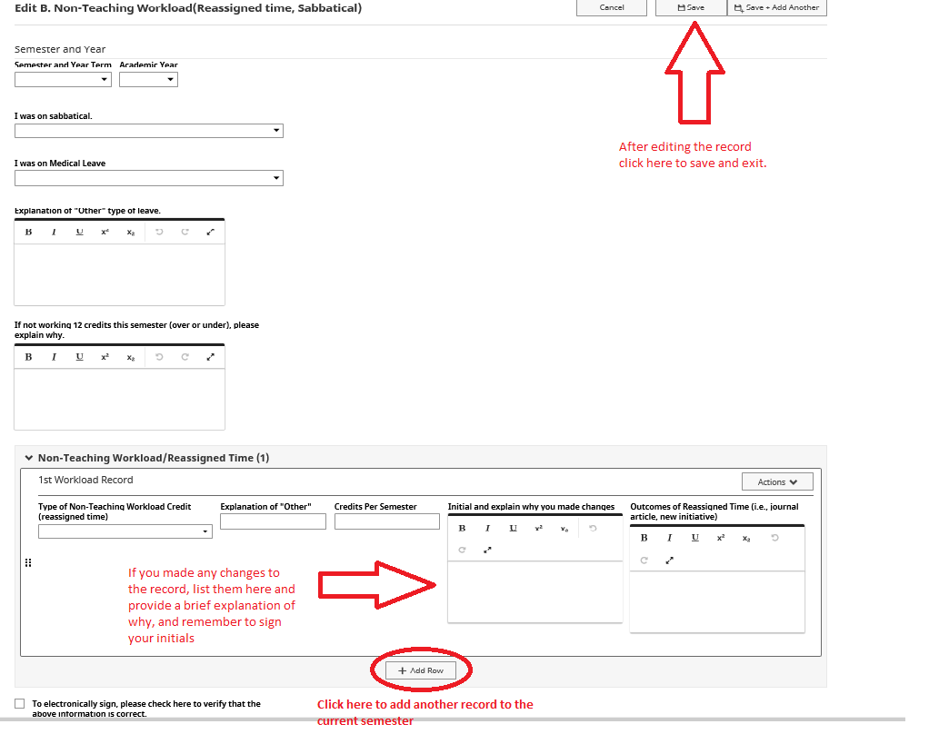
If a faculty member is missing a workload record, then you will need to add a missing record by clicking +Add Row in the bottom center of the screen. Please be sure to click Save when you are finished.

For faculty who do not have any reassigned credits for the Spring 2019-2020 semester, but who should have them, click + Add New Item in the upper right-hand corner of the screen as shown below. Starting with semester and year, work your way down the page, entering the applicable information into the corresponding fields. If you have more than one workload record to add, click +Add Row to add additional items. Please be sure to click Save when you are finished.
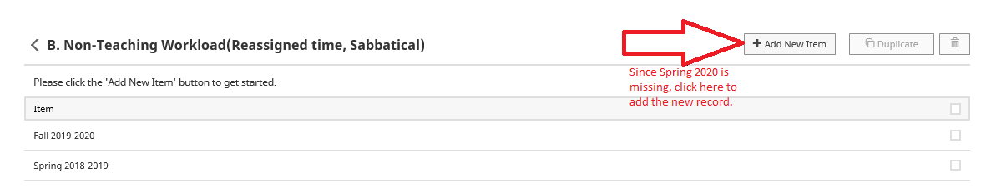

C. Credit Load History and Remainder
To correct the information for a particular faculty member’s Accrued Workload Remainder, please go to screen C. Credit Load History and Remainder. Here you will need to correct the information for each faculty member who has an error in their FT Faculty Workload Summary Report – Spring 2020. Click on Spring 2019-2020 and input any changes into the box below the remainder. Do not attempt to edit the remainder in the box, but input what you think the correct remainder is into the box labeled with “Dept. Chair” and then place your initials inside the box. Next, email Maureen, the faculty member, and the dean with an explanation as to what and why changes are being suggested. Once Maureen has received written approval from the Dean, she will go in and make the necessary changes. These changes will be completed before the faculty members themselves are invited to access DMAI to verify their own information. Please be sure to click Save after making any edits. An example of a record in screen C. is shown on the next page.
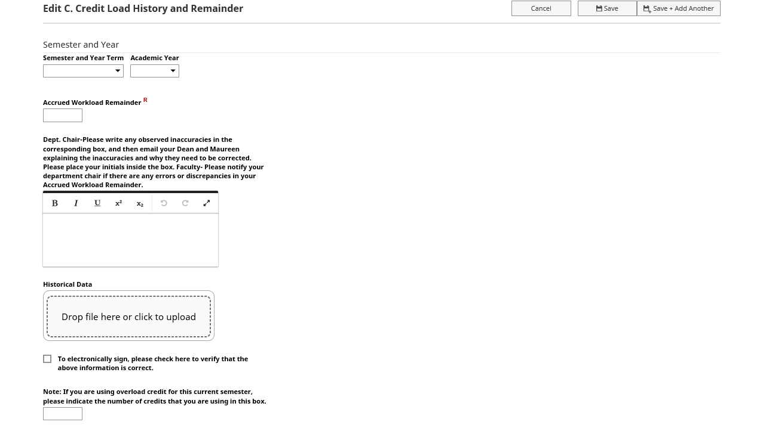

To Continue to the Next Faculty Member (if necessary):
In order to proceed to the next faculty member’s information in DMAI, navigate back to the activities menu and hover your cursor over Activities and select Manage Data, just as you did for the first faculty member. Please continue to do this process for each faculty member in your department who has an error. All full-time faculty will be invited to go into DMAI themselves and view their own information to electronically sign off after department chairs have been given 3 weeks to review the report.
If you have any questions, please contact Maureen at gilbriderem1@southernct.edu or 27054.

